

**TRENDS**

**Developed By:**

**Tatva Shah : 205170686002**

**Umang Patel : 205180696047**

**Aryan panchal : 205170686026**

**Group No : IMCA_9_G10**

**Under the Guidance of : Pratvi ma’am**

**Submitted To :**

**L.J. Institute of Computer Application**

**L.J. INSTITUTE OF ENGINEERING & TECHNOLOGY**

Near Nagdev Kalyan Mandir, Near Sarkhej Cross Roads,

Sarkhej-Gandhinagar Highway  Ahmedabad - 382210  
Ph. No. : 079 29296364



***CERTIFICATE***

**Enrollment No**: **205170686002**

This is to certify that Mr. / Ms. **Tatva Shah** studying in Integrated Master of Computer Applications, Semester IX, Roll No **ICA-49** has satisfactorily completed his/her Project Titled **Trends**  under the supervision of **Prof. Pratvi ma’am**

**Internal Guide Name :** **Signature**

Prof. Pratvi ma’am

**Date of Submission:**

**Director**

**Prof. Aalok Manke**

**L.J. INSTITUTE OF ENGINEERING & TECHNOLOGY**

Near Nagdev Kalyan Mandir, Near Sarkhej Cross Roads,

Sarkhej-Gandhinagar Highway  Ahmedabad - 382210  
Ph. No. : 079 29296364



***CERTIFICATE***

**Enrollment No**: **205180696047**

This is to certify that Mr. / Ms. **Umang Patel** studying in Integrated Master of Computer Applications, Semester IX, Roll No **IET- 42** has satisfactorily completed his/her Project Titled **Trends** under the supervision of **Prof. Pratvi ma’am**

**Internal Guide Name:** **Signature**

Prof. Pratvi ma’am

**Date of Submission:**

**Director**

**Prof. Aalok Manke**

**L.J. INSTITUTE OF ENGINEERING & TECHNOLOGY**

Near Nagdev Kalyan Mandir, Near Sarkhej Cross Roads,

Sarkhej-Gandhinagar Highway  Ahmedabad - 382210  
Ph. No. : 079 29296364



***CERTIFICATE***

**Enrollment No**: **205170686026**

This is to certify that Mr. / Ms. **Aryan Panchal** studying in Integrated Master of Computer Applications, Semester IX, Roll No **ICA-19** has satisfactorily completed his/her Project Titled **Trends**  under the supervision of **Prof. Pratvi ma’am**

**Internal Guide Name :** **Signature**

Prof. Pratvi ma’am

**Date of Submission:**

**Director**

**Prof. Aalok Manke**

**Acknowledgement**

It is our privilege to express our sincerest regards to our faculty and project guide, **Prof. Pratvi ma’am** for their valuable inputs, able guidance, encouragement, whole-hearted cooperation and constructive criticism throughout the duration of our project. We deeply express our sincere thanks to our Head of Director **Dr. Monica Gahlawat** for encouraging and allowing us to present the project on the topic “**Trends**” at our department premises for the partial fulfilment of the requirements leading to the award of Integrated Master of Computer Application (IMCA) degree. We take this opportunity to thank all our lecturers who have directly or indirectly helped our project. Last but not the least we express our thanks to our friends for their cooperation and support.

Table of Contents

1. INTRODUCTION 7

1.1 EXISTING SYSTEM 9

1.2 NEED FOR THE NEW SYSTEM 10

1.3 OBJECTIVES OF THE NEW SYSTEM 11

1.4 PROBLEM DEFINITION 11

1.5 CORE COMPONENTS 12

❖ User Module 12

❖ Admin Module 12

1.6 PROJECT PROFILE 13

1.7 ASSUMPTIONS AND CONSTRAINTS 13

1.8 ADVANTAGE AND LIMITATIONS OF THE PROPOSED SYSTEM 14

❖ Advantages 14

❖ Disadvantages 15

2. REQUIRMENT DETERMINATION AND ANALYSIS 16

2.1 Requirement Determination: 16

2.2 TARGETED USERS 17

3. SYSTEM DESIGN 18

3.1 Use case Diagram: 18

3.2 Class Diagram: 19

3.3 Interaction Diagram 20

❖ Admin Add products: 20

❖ Admin Update Product: 21

❖ Admin Delete Product: 22

❖ Customer Add Product to Cart: 23

❖ Customer Delete Products from Cart : 24

3.4 Activity Diagram 25

❖ Admin Manage Product: 25

❖ Customer Add Products to Cart: 26

❖ Customer Place Order: 27

3.5 Data Dictionary: 28

❖ **Table Name:** Registration 28

❖ **Table Name:** Category 28

❖ **Table Name:** Sub- category 29

❖ **Table Name:** Order 29

❖ **Table Name:** Products 29

❖ **Table Name:** Cart 30

❖ **Table Name:** Payment 30

4. Development 31

4.1 Coding Standards 31

❖ Coding Style 31

❖ Formatting 31

❖ Commenting 31

4.2 Screen Shots 32

❖ Admin 32

❖ Customer 42

5. Agile Documentation 51

5.1 Agile Project Charter: 51

5.2 Agile Roadmap / Schedule 52

5.3 Agile Project Plan 53

5.4 Agile User Story 55

5.5 Agile Release Plan 56

5.6 Agile Sprint Backlog 57

5.7 Agile Test Plan 58

5.8 Earned-value and burn charts 63

6. Proposed Enhancements 64

6.1 Proposed Enhancements 64

7. Conclusion 66

7.1 Conclusion 66

8. Bibliography 66

8.1 Site References : 66

# INTRODUCTION

* Online shopping is a form of E-commerce which allows consumers to directly buy goods or services from the Internet using a web browser or a mobile app. Consumers find a product of interest by visiting the website of the retailer directly or by searching among alternative vendors using a shopping search engine, which displays the same product's availability and pricing at different e-retailers. As of 2024, customers can shop online using a range of different computers and devices, including desktop computers, laptops, tablet computers and smartphones.
* Online customers must have access to the Internet and a valid method of payment in order to complete a transaction, such as a credit card, or a service such as PayPal. For physical products (e.g., paperback books or clothing). An online store may also be called an e-web-store, e-shop, e-store, Internet shop, web-shop, web-store, online store, online storefront and virtual store. Online stores are usually available 24 hours a day.
* In the present scenario, the biggest market for this (online shopping) business is by highly educated people, mostly. This system has been designed keeping in mind all the aspects such as loading the data, complexity, and maintaining the security of user credentials. Here in this system, complexity refers to the total number of features being provided to users, and their smooth arrangement and functioning required.
* Our clothing store is the base on the customer can easy to buy product in the online website. We provide the online payment system in our website For easy to buy product. The system would be easy to use and hence make the shopping experience pleasant for the users.
* People in large number are doing online shopping today, and it is not only because it is convenient as one can shop from home, but also because there is an number of varieties available, with a high competition of prices, and also it is easy to navigate for searching regarding any particular item.

## EXISTING SYSTEM

* The present scenario for shopping is to visit the shops and market manually and then from the available product list one needs to choose the item h e or she wants and then pay for the same item mainly in cash mode is done, as not every society is well educated and aware to use net banking or card modes or wallets etc.
* Also, not really good markets exist everywhere, so many times good markets become out of reach for certain people.
* In the proposed system customers need not go to the shops for purchasing the products.

## NEED FOR THE NEW SYSTEM

* There are large numbers of commercial Online Shopping websites offering large number of products tailored to meet the shopping interests of large number of customers. These online marketplaces have thousands of products listed under various categories.
* **Convenience:** This is the one of the main reasons that online shopping become so popular, as it allows you to switch stores and products by clicking a button rather than traveling to a new store.
* **No crowds:** You hate crowds when you're shopping. Especially during festivals or special events, they can be such a huge headache. Grumpy, annoying, and smelly people also annoy me when I'm out shopping. Plus, parking becomes a huge issue. Al of these problems can be avoided when you "shop online".
* **No need to travel:** People don't usually like to move a lot to get what they want. Of course, nothing can compete with experience of going to a cloth boutique and buying what you want, but normally people just don't want to travel.

## OBJECTIVES OF THE NEW SYSTEM

* The objective of this system is to provide easy assistance to both the customer as well as the merchant with proper database and information.
* The purpose of online clothing store is to save time, save money. Through online clothing store one can save his valuable time. One can watch and select thing he wants buy. Through online clothing store we can save over money because prices are less then market prices and we receive our bought things at home. No need to go anywhere and do shopping. We can get different varieties of things online and we can choose which one we want.

## PROBLEM DEFINITION

* There are expenses for traveling from house to shop. More over the shop from where we would like buy something may not open 24*7. In order to overcome these, we have online clothing store solution. i.e. One place where we can get all required products online.

## CORE COMPONENTS

### User Module

* Allow to user Sign Up
* Allow to user Login page
* Allow to user Shop view
* Allow to user Cart view
* Allow to user Payment Get way
* Allow to user Order view
* Allow to user Logout

### Admin Module

* Allow to Admin Login
* Allow to Admin Manage customer
* Allow to Admin Manage order
* Allow to Admin Manage product
* Allow to Admin Change password
* Allow to Admin logout

## PROJECT PROFILE

|  |  |
| --- | --- |
| Project Title | Trends |
| Components/Modules | Admin  User |
| Institute Name | L.J. Institute of Computer Applications |
| Duration | 3 months |
| Project Internal Guide | Prof. Pratvi ma’am |
| Software used   * Framework * Backend | Laravel  MySQL, PHP |
| Operating System | Macbook M1Chip |
| Team Members | * **Tatva Shah ICA-49** * **Umang Patel IET-42** * **Aryan Panchal ICA-19** |

## ASSUMPTIONS AND CONSTRAINTS

* This project can be modified in future according to the need of Customer and administrator.

## ADVANTAGE AND LIMITATIONS OF THE PROPOSED SYSTEM

### Advantages

* **Shop From Any Location: -**

Online shopping gives you the freedom to choose where you want to shop. You could be lounging on your couch, or even be on your lunch break at work, and you can still shop for "clothing online". This way, you don't have to worry about going anywhere just to go shopping.

* **Time to Convenience:-**

Online shopping allows you to save a lot of time and energy. It makes it easier to find the items you want, as you have access to endless brands and online stores from your computer or smartphone.

* **A Greater Variety of choices: -**

Shopping for "clothing online" exposes you to a variety of shopping options to choose from. You are no longer limited to the options provided by the physical stores near you.

* **Shop Internationally: -**

Online shopping exposes you t o a global platform. You are no longer limited to your location when shopping for clothing you can purchase items from your favorite brand at any time and from any place.

* **No Crowds: -**

Shopping for "clothing online" allows you to enjoy privacy while you shop. You don't have to experience the discomfort of being in a crowded store, and you won't have to wait in long queues.

### **Disadvantages**

* **Delay in the delivery: -**

**In case of offline shopping, you can receive the product then and there. But, this does not happen in online shopping.**

* **You can't touch the product: -**

**The sad part of online shopping is, you cannot touch the product and feel how it is.**

* **You cannot bargain:-**

**Indians are good at bargaining. You can bargain only in case of offline shopping, not in the case of online shopping.**

# REQUIRMENT DETERMINATION AND ANALYSIS

## Requirement Determination:

* Gathering requirements for a user-friendly interface, secure payment gateway, efficient inventory management system, and responsive customer support.
* **Functional Requirement:**

**Hardware Requirement**

* Processor: macOS m1 chip
* RAM: 8GB
* Hard Disk: 256GB

**Software Requirement**

* Operating System: Windows
* Front-end: Visual Studio code
* Back-end: MY SQL
* **Non-Functional Requirement:**
* **Reliability Requirement:** Our system will provide a reliable environment to both user and admin. All orders should be reaching at the admin without any errors.
* **Usability Requirement:** This system is designed for user friendly environment and ease of use.
* **Security:** This system must automatically logged out after all customers inactivity for long duration. The system backend database accessible by only specific administrator.

## TARGETED USERS

* any visitor can go through our website and get information about the cloth.
* The User can search the clothes by brands.
* But if they want to place order or add product to cart/purchase then they must have to register and then login.

# SYSTEM DESIGN

## 3.1 Use case Diagram:

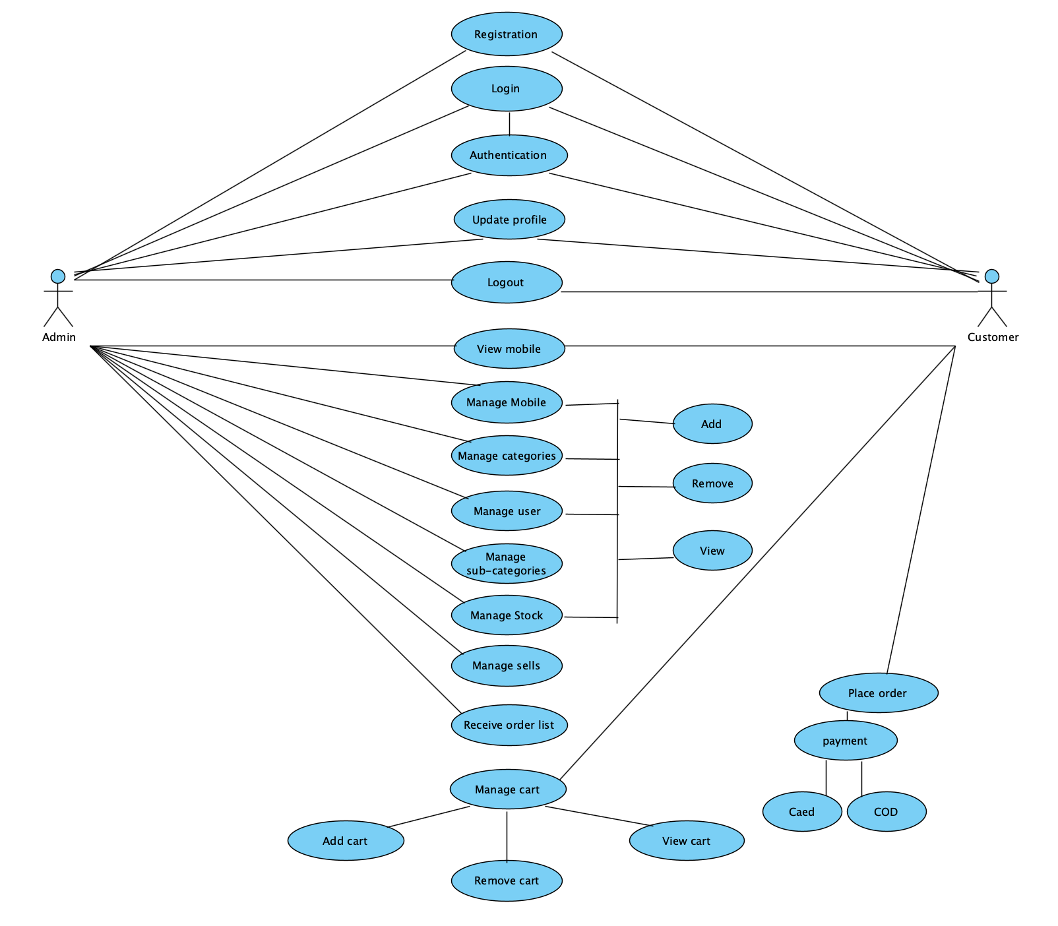

## 3.2 Class Diagram:

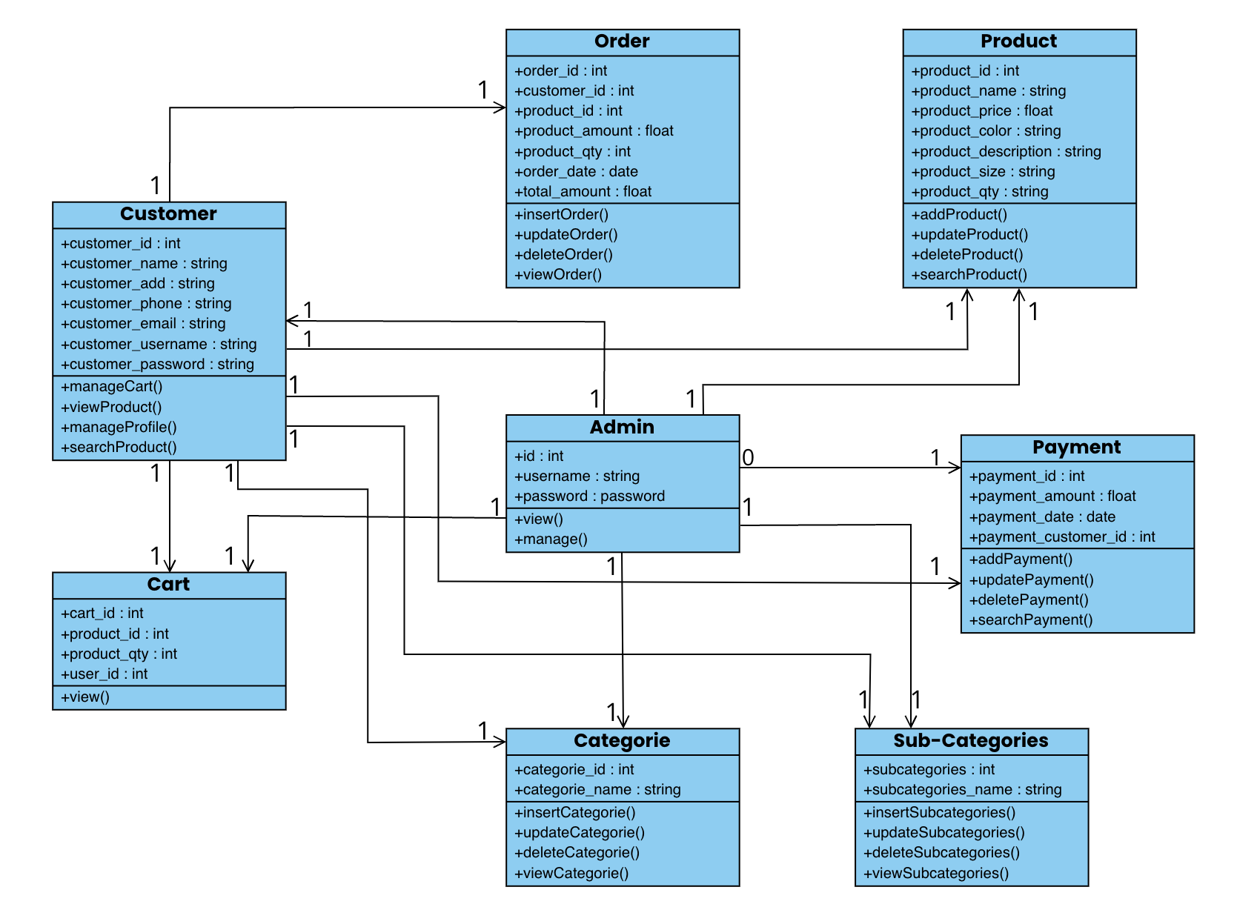

## 3.3 Interaction Diagram

### Admin Add products:

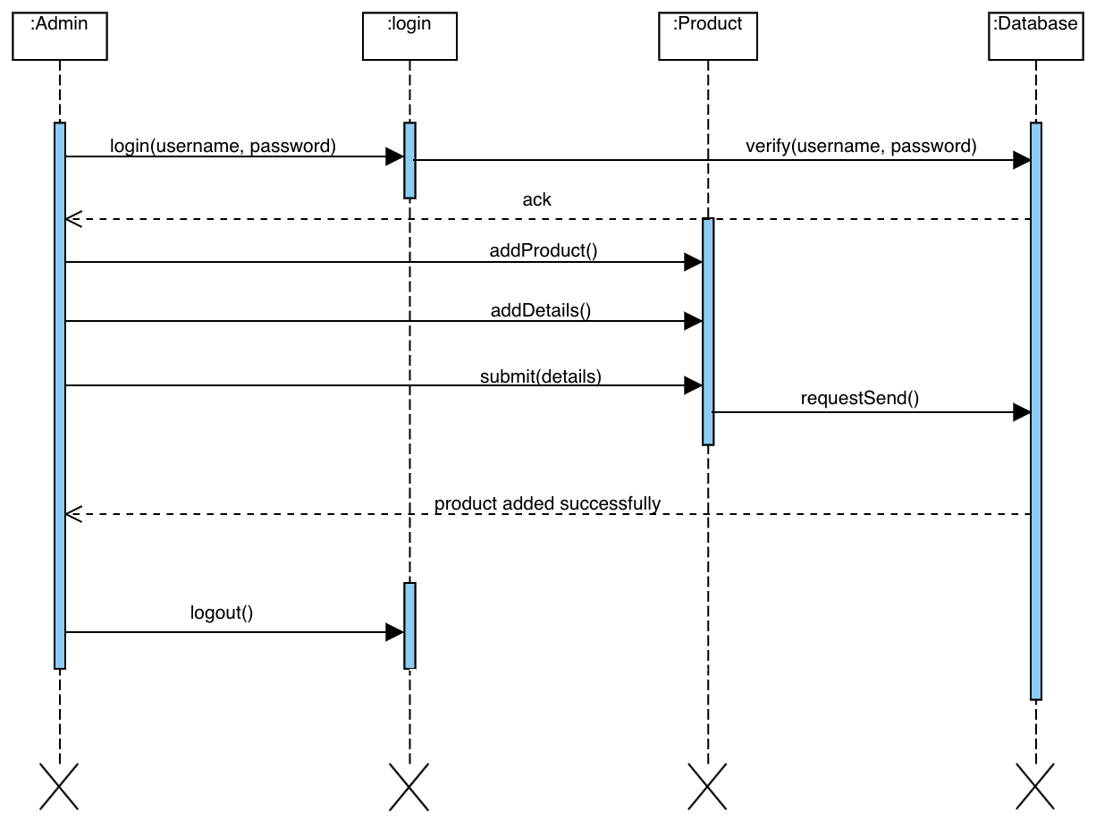

### Admin Update Product:

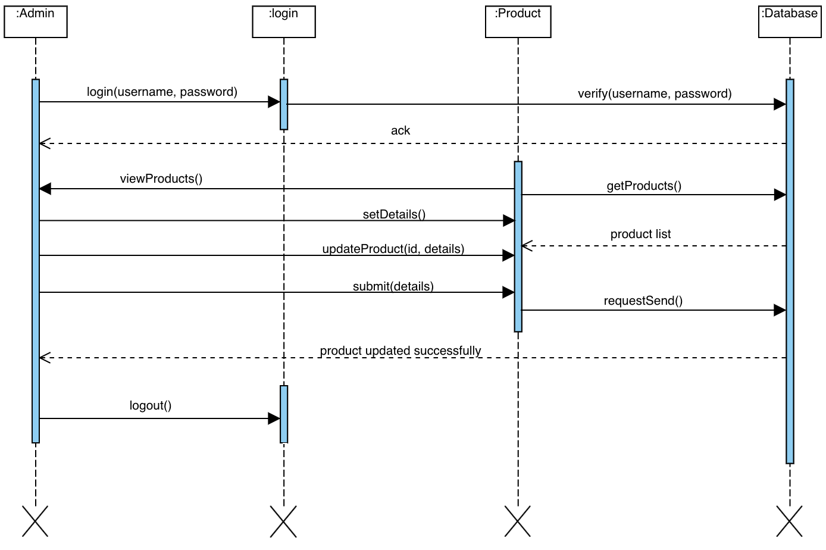

### Admin Delete Product:

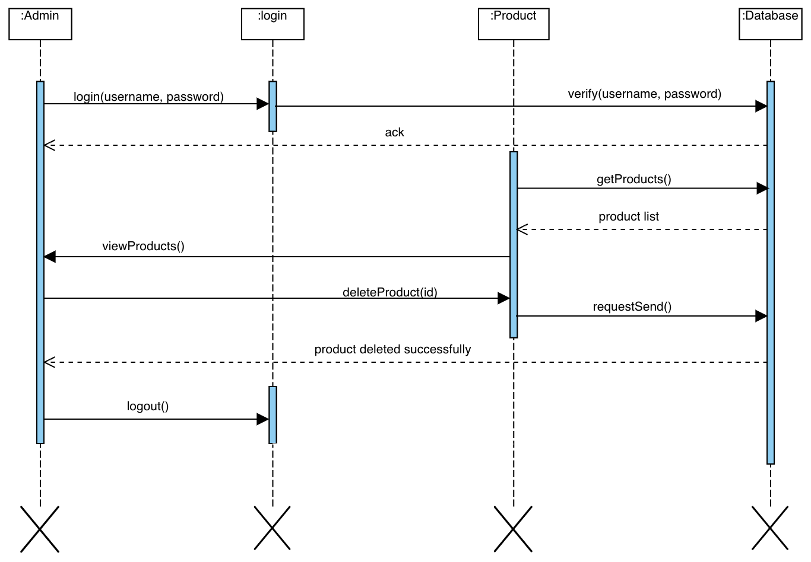

### Customer Add Product to Cart:

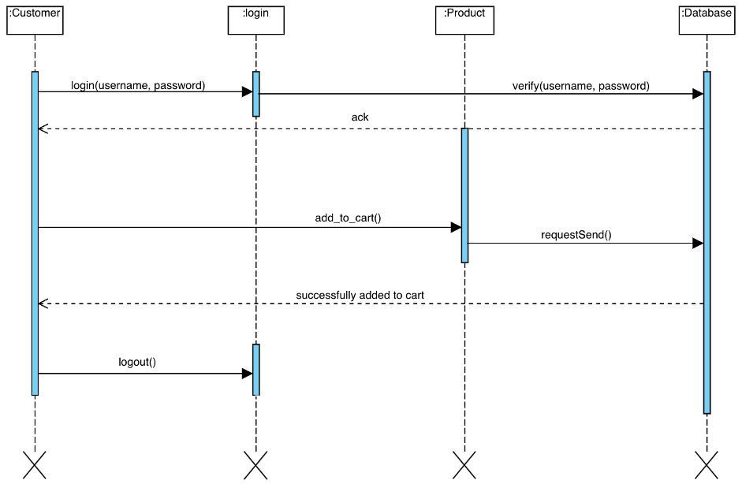

### Customer Delete Products from Cart :

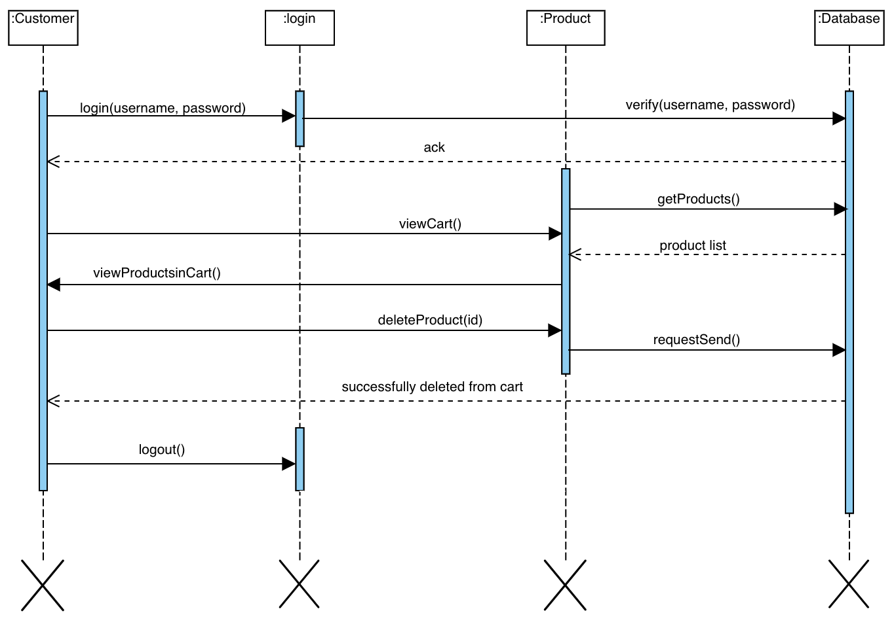

## 3.4 Activity Diagram

### Admin Manage Product:

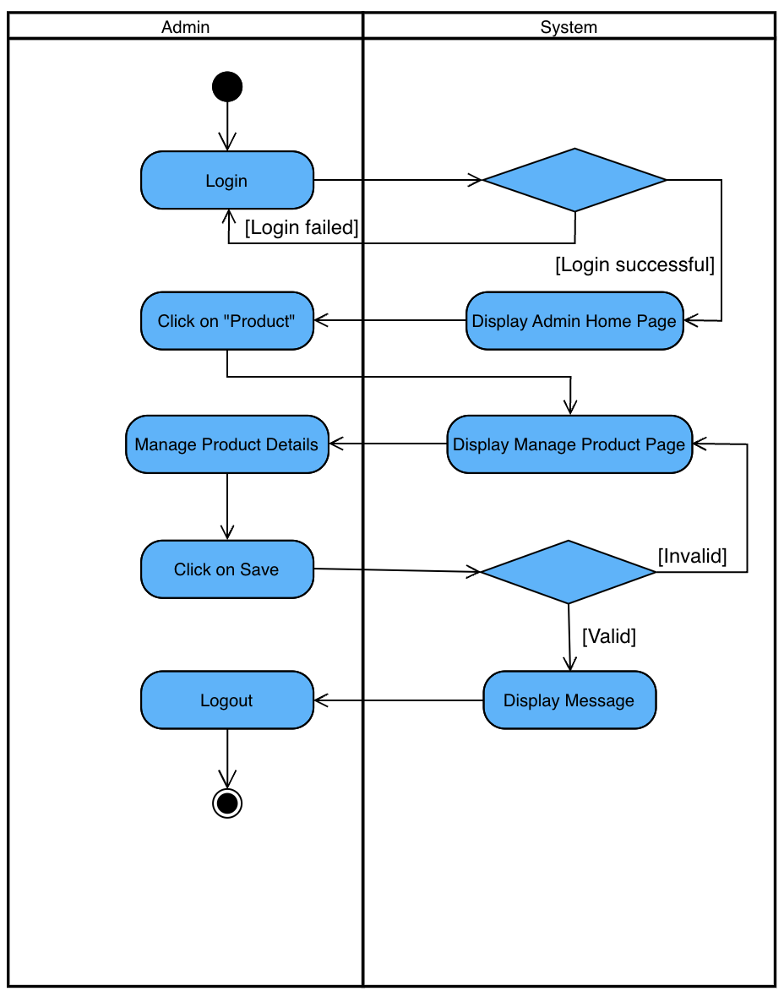

### Customer Add Products to Cart:

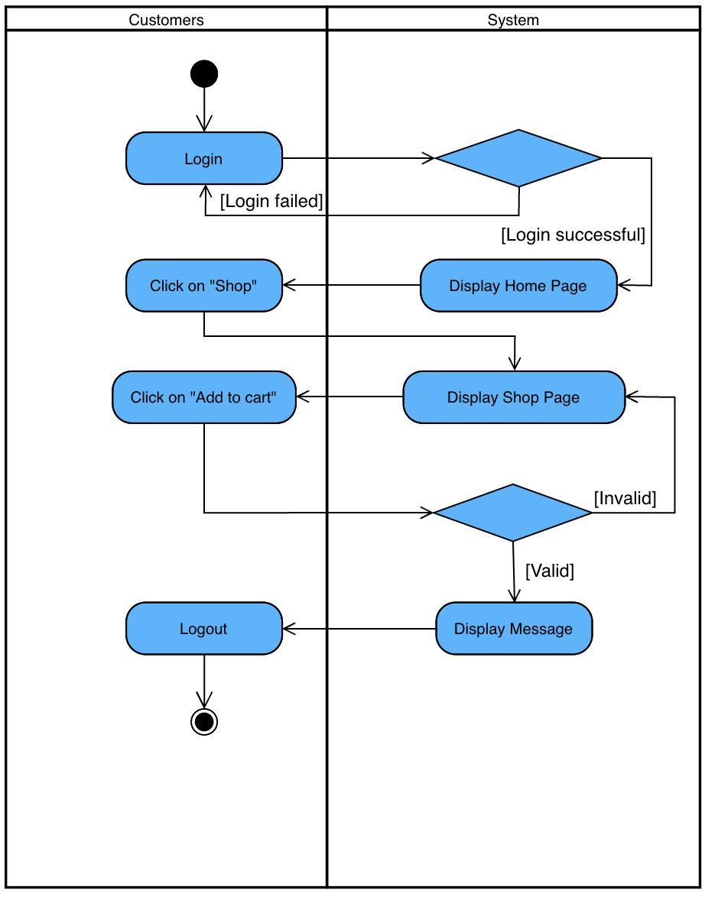

### Customer Place Order:

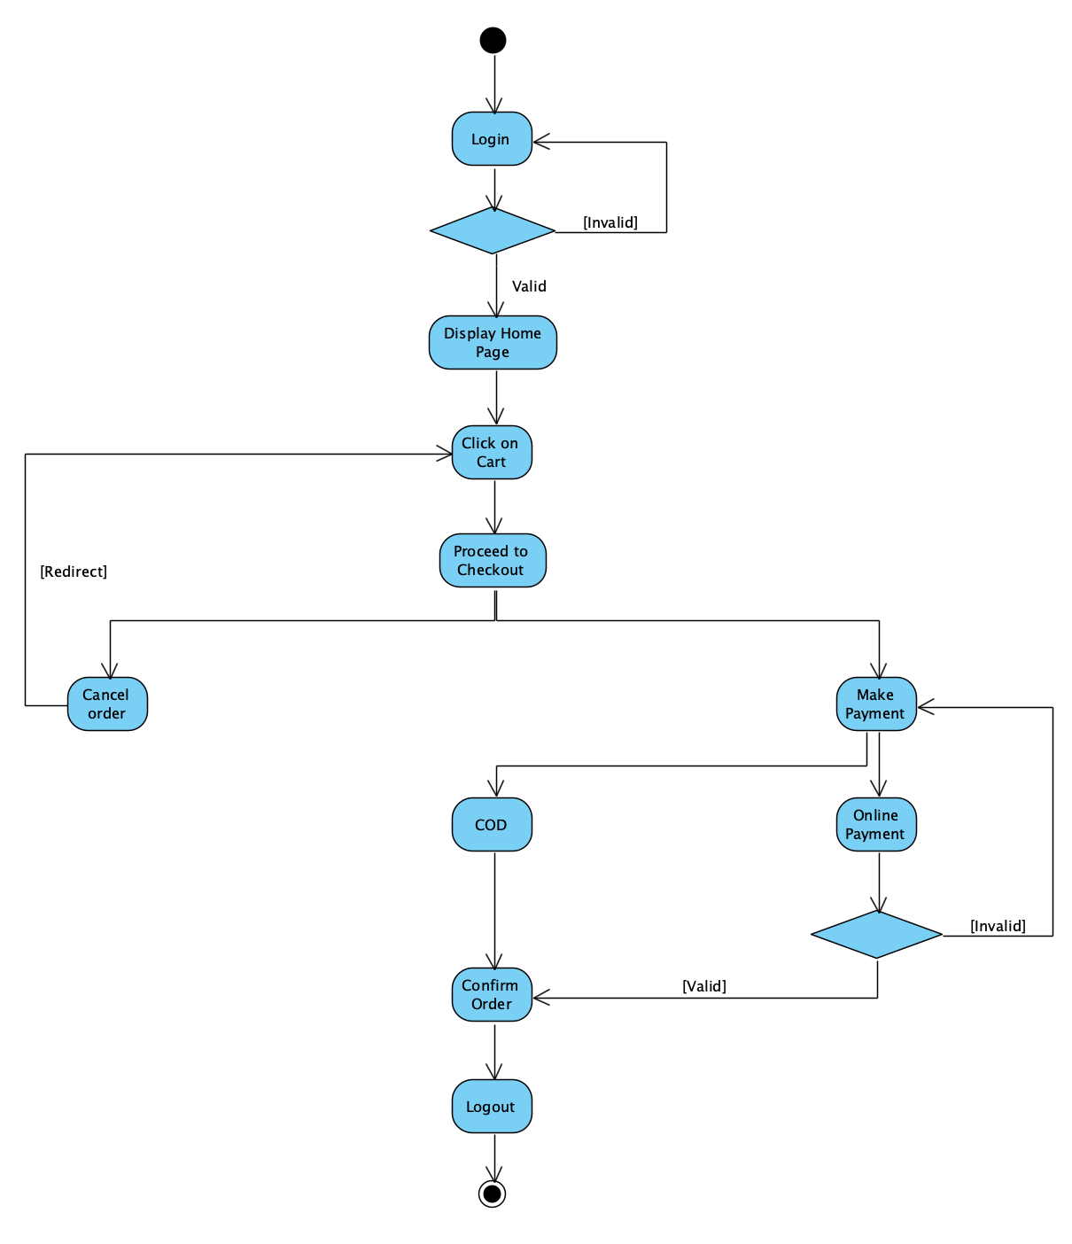

## **3.5 Data Dictionary:**

### **Table Name:** Registration

|  |  |  |  |  |  |
| --- | --- | --- | --- | --- | --- |
| Field | Type | Size | Constraint | Description | Example |
| User_id | Int | 11 | Primary key | Id of user | 1 |
| F_name | Varchar | 50 | - | First Name of user | Umang |
| L_name | Varchar | 30 | - | Last Name of user | Patel |
| Email | Varchar | 20 | Unique key | Email-id of user | abc@gmail.com |
| Username | Varchar | 20 | Unique key | Username | Abcd |
| Password | Varchar | 15 | - | Password | 1234 |
| Phone no | int | 10 | Unique key | Phone no | 1234567890 |
| address | varchar | 50 | - | Address | 1,ahmedabad |

### **Table Name:** Category

|  |  |  |  |  |  |
| --- | --- | --- | --- | --- | --- |
| Field | Type | Size | Constraint | Description | Example |
| Category_id | int | 20 | - | category | 1 |
| Category_name | Varchar | 20 | Unique key | Category name | External Kids, Men, Women, accessories |

### **Table Name:** Sub- category

|  |  |  |  |  |  |
| --- | --- | --- | --- | --- | --- |
| Field | Type | Size | Constraint | Description | Example |
| Sub-category_id | int | 10 | - | Sub-category | 1 |
| Sub-category_name | Varchar | 20 | Unique key | Sub-category name | Different type of clothing |

### **Table Name:** Order

|  |  |  |  |  |  |
| --- | --- | --- | --- | --- | --- |
| Field | Type | Size | Constraint | Description | Example |
| Order_id | Int | 15 | Primary Key | Id of Order | 7996 |
| Order_date | Date | - | Date | Date of Order | 29-02-2024 |
| Customer_id | Varchar | 15 | - | Name of Customer | Tatva |
| Cart_id | Varchar | 20 | - | Product name | Men T-shirt |

### **Table Name:** Products

|  |  |  |  |  |  |
| --- | --- | --- | --- | --- | --- |
| Fields | Type | Size | Constrain | Description | Example |
| Product_id | Int | 12 | Primary key | Unique id | 12345678902 |
| Product_name | Varchar | 25 | Foreign key | Name of product | Adidas, PUMA, ZARA etc. |
| Product_price | int | 10 | - | Price of product | 5000 |
| Product_description | char | 50 | Foreign key | Product  description | information |
| Product_image | image | 6 | - | Product image | image |

### **Table Name:** Cart

|  |  |  |  |  |  |
| --- | --- | --- | --- | --- | --- |
| Field | Type | Size | Constraint | Description | Example |
| Cart_id | Int | 15 | Primary Key | Id of Booking | 77 |
| Product_id | Varchar | 50 | Unique key | Name of cloth | Adidas, PUMA, ZARA etc. |
| Total_quantity | Int | 20 | - | Total cloth | 3 |
| Price | Int | 20 | - | Price of clothes | 2500 |

### **Table Name:** Payment

|  |  |  |  |  |  |
| --- | --- | --- | --- | --- | --- |
| Field | Type | Size | Constraint | Description | Example |
| Customer_id | Int | 15 | Primary_Key | Id of Customer | 155000 |
| Order_id | int | 10 | Unique_key | Order name | 10 |
| Cash/ online/upi | Varchar | 20 | - | Payment |  |
| Amount | Int | 20 | - | Price of Product | 2000/- |

# Development

## Coding Standards

### Coding Style

* The following should be kept in mind to maintain a coding style. Such are, Layout, Format, Indentation, organizing code meaningfully, code must be readable and consistent which makes it easy to understand and maintain further.

### Formatting

* Always use comments for description.
* Always use curly braces {and} in conditional statements.

Example:

if (condition)

{

// comment

}

* Order declarations within type groups based upon access modifier and their accessibility.
* Public
* Protected
* Internal
* Private

### Commenting

* All comments should be written in U.S. English.

Use # or “””…””” but do NOT use /* */.

## Screen Shots

### Admin

1. Admin Login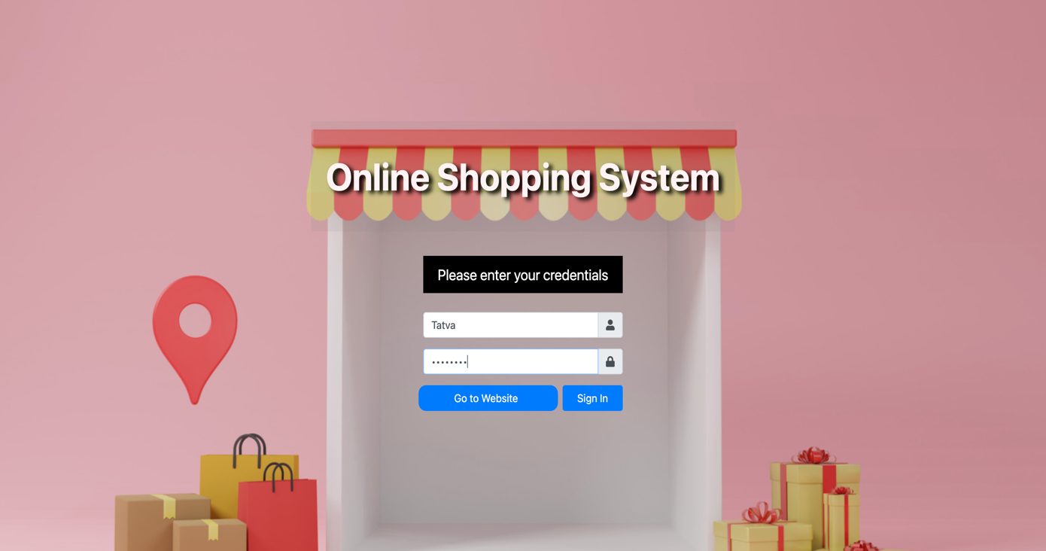

2. Admin Dashboard

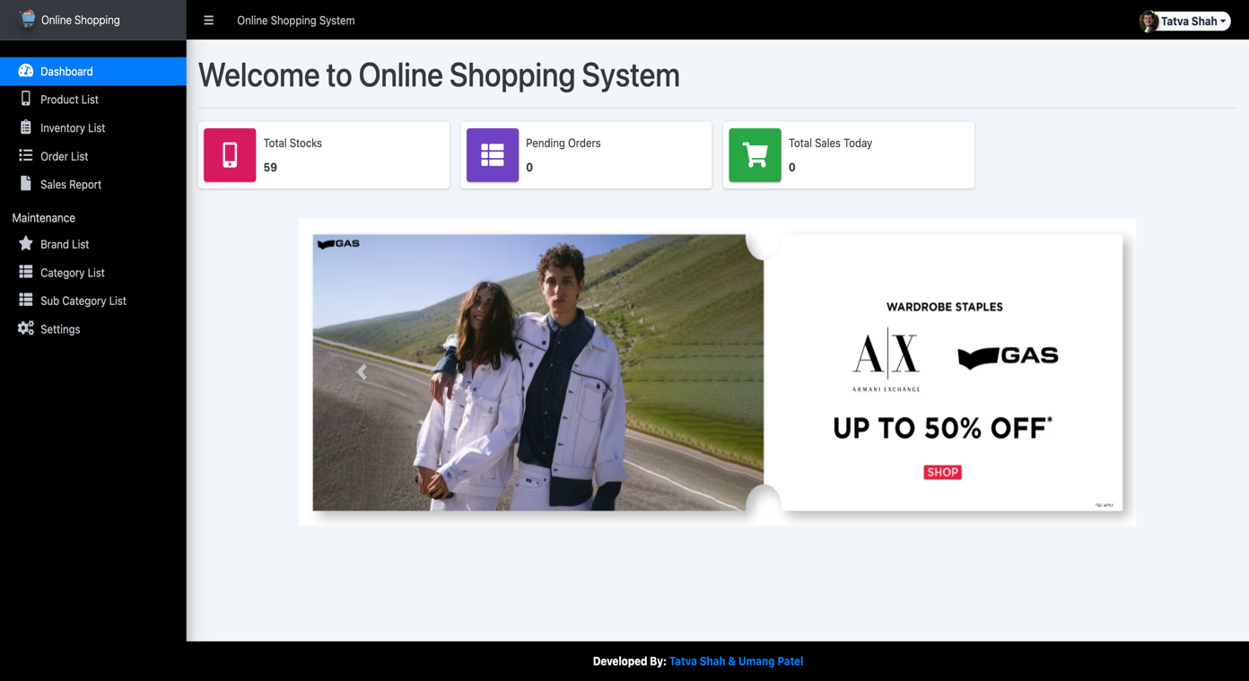

3. Admin Product list

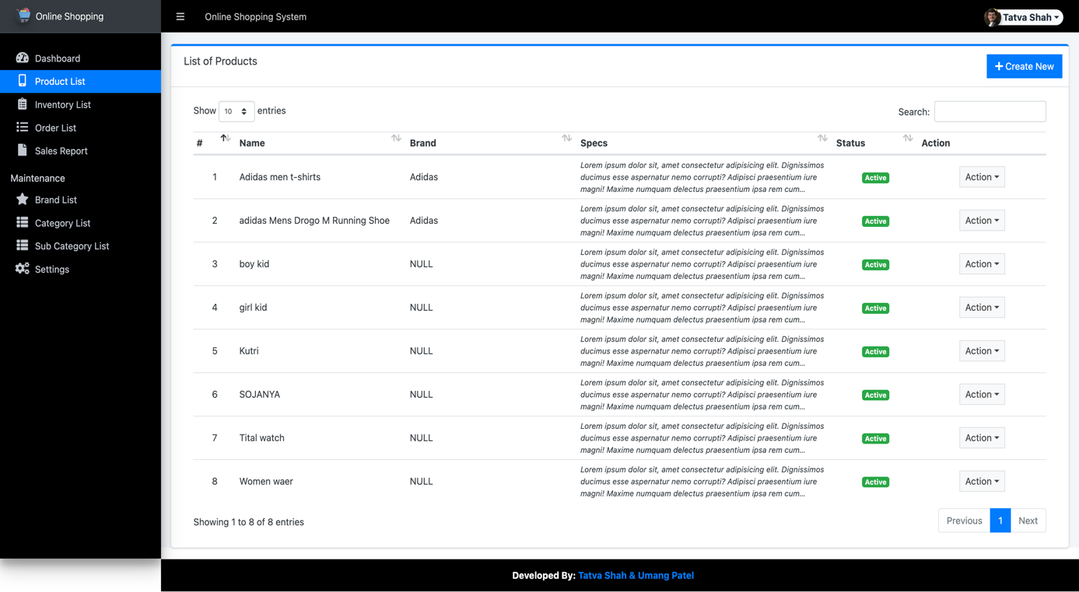

4. Admin Update Product

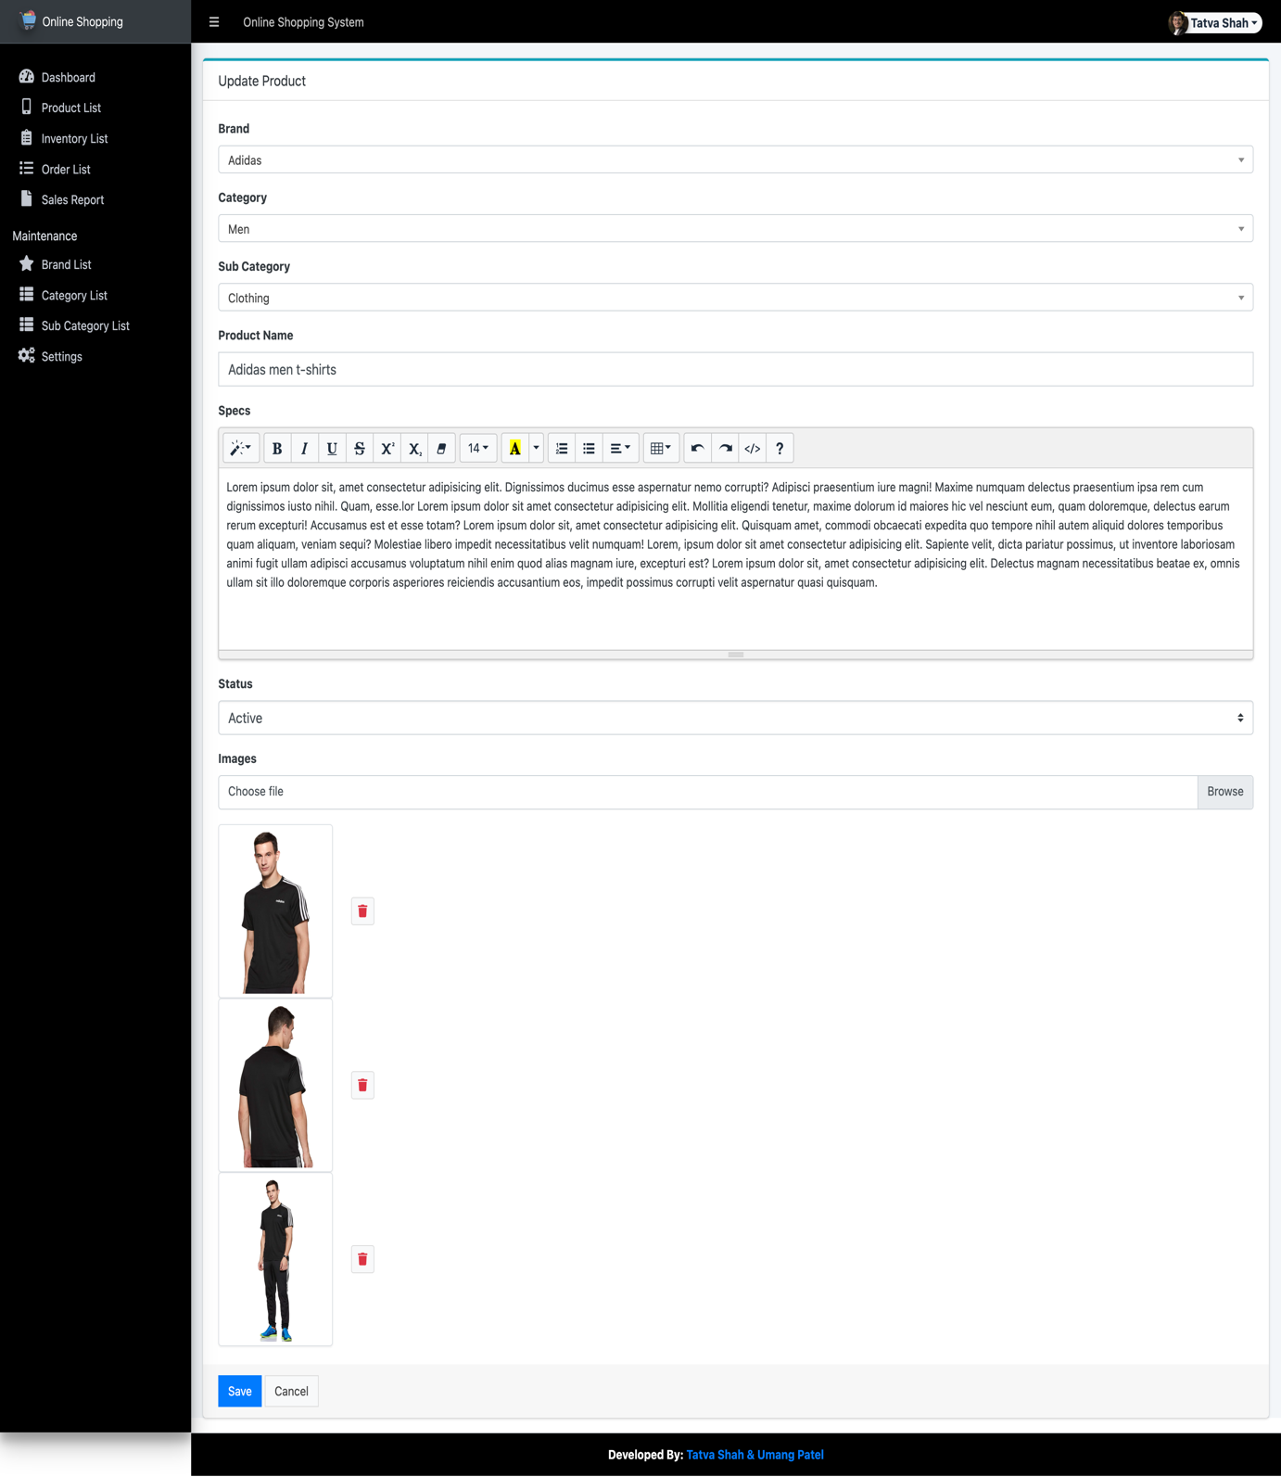

5. Admin Inventory list

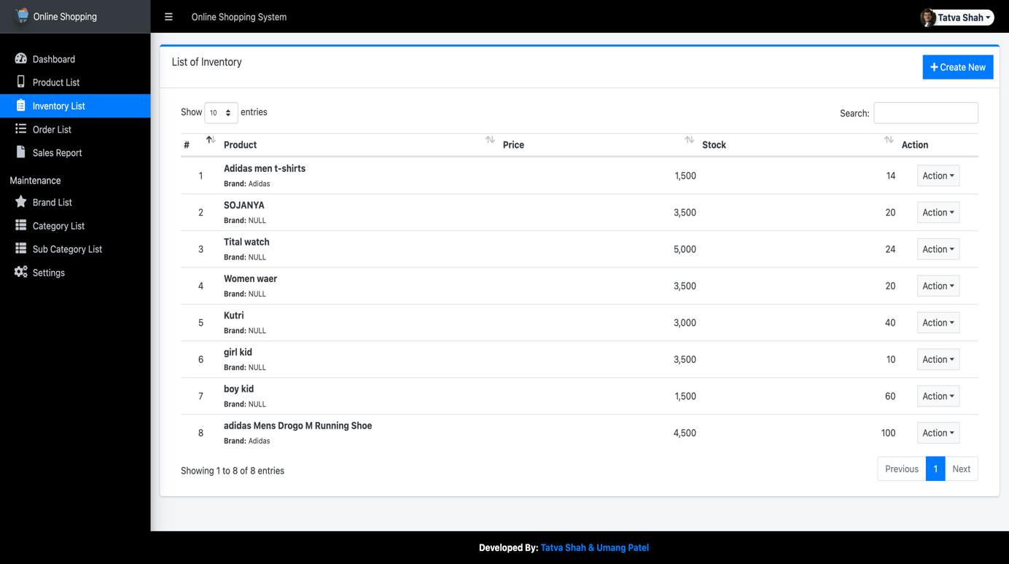

6. Admin Add Inventory

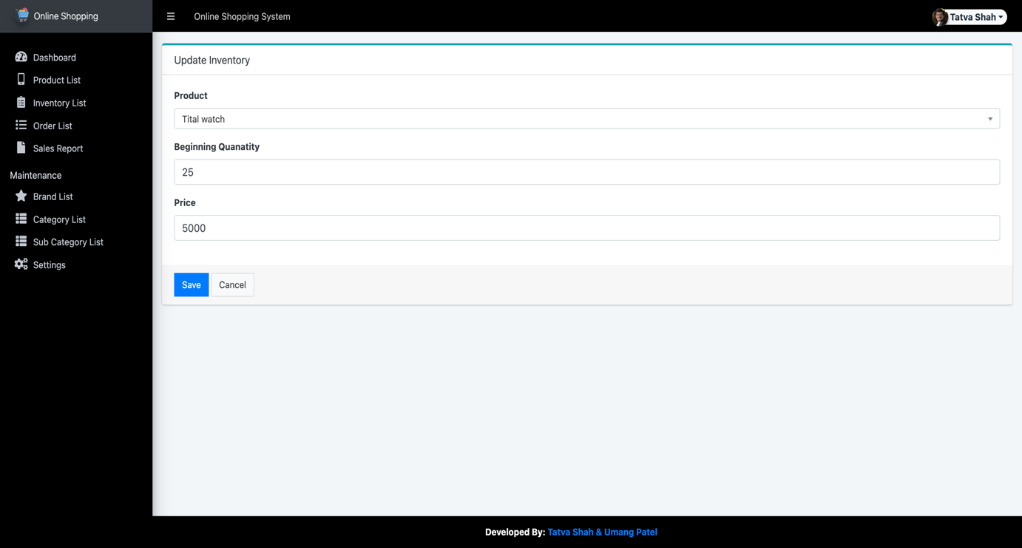

7. Admin Order list

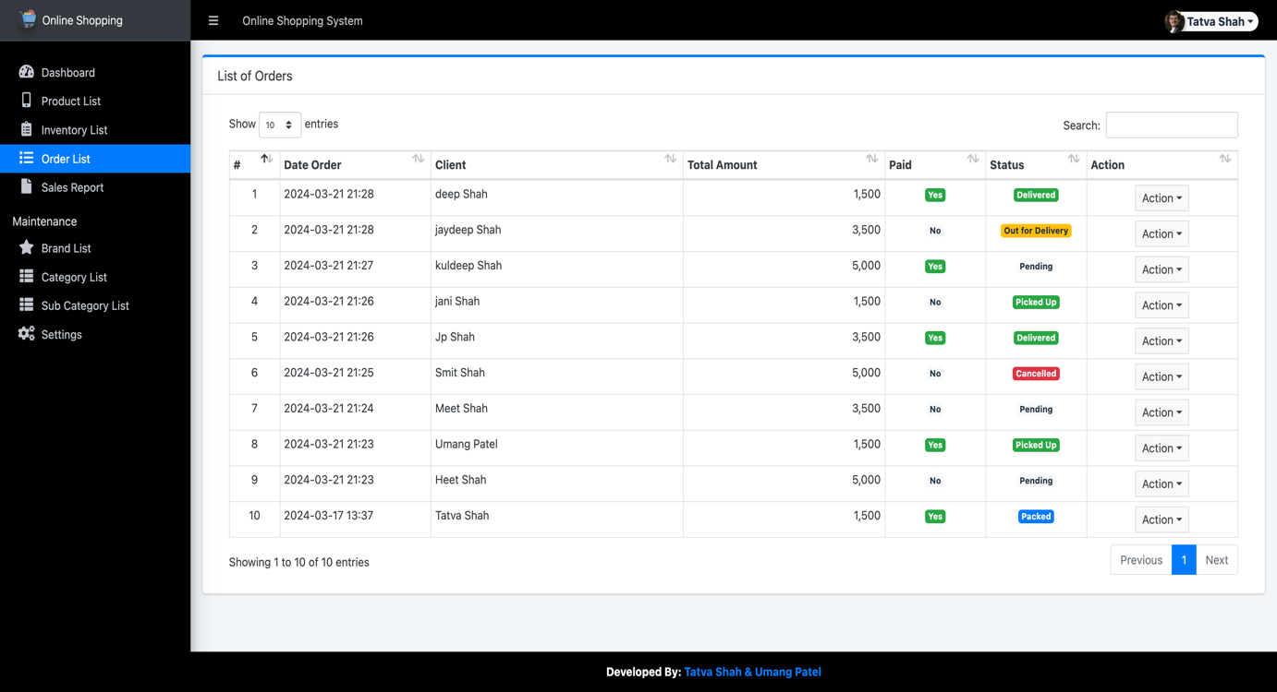

8. Admin Order Update

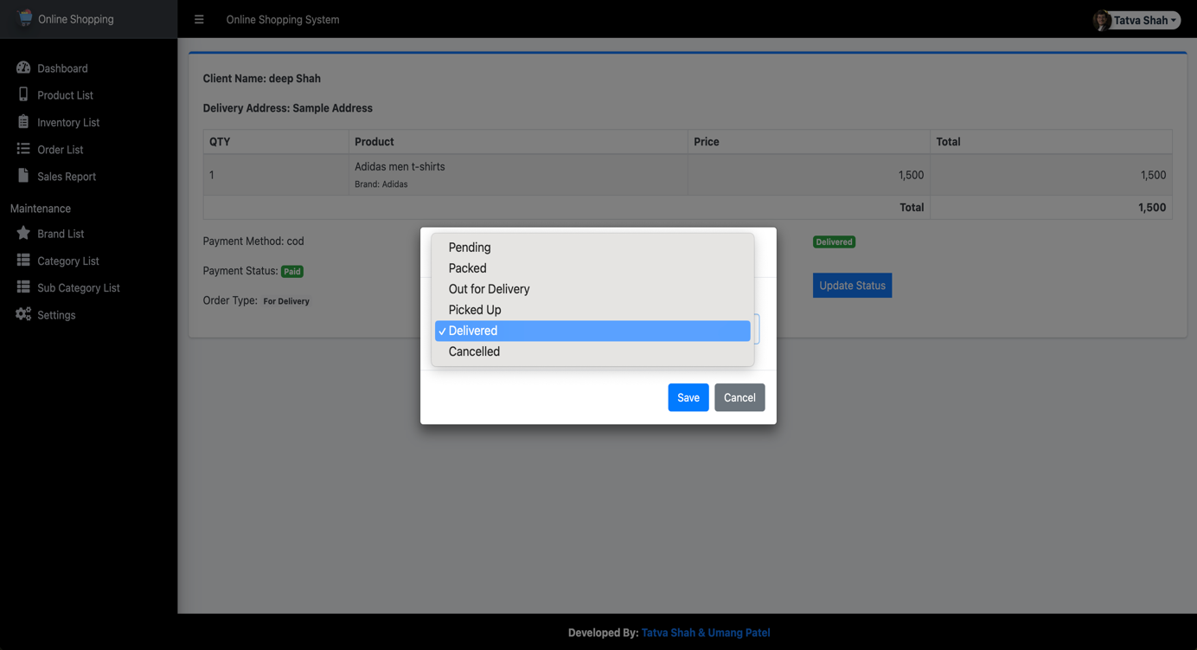

9. Admin Sales Report

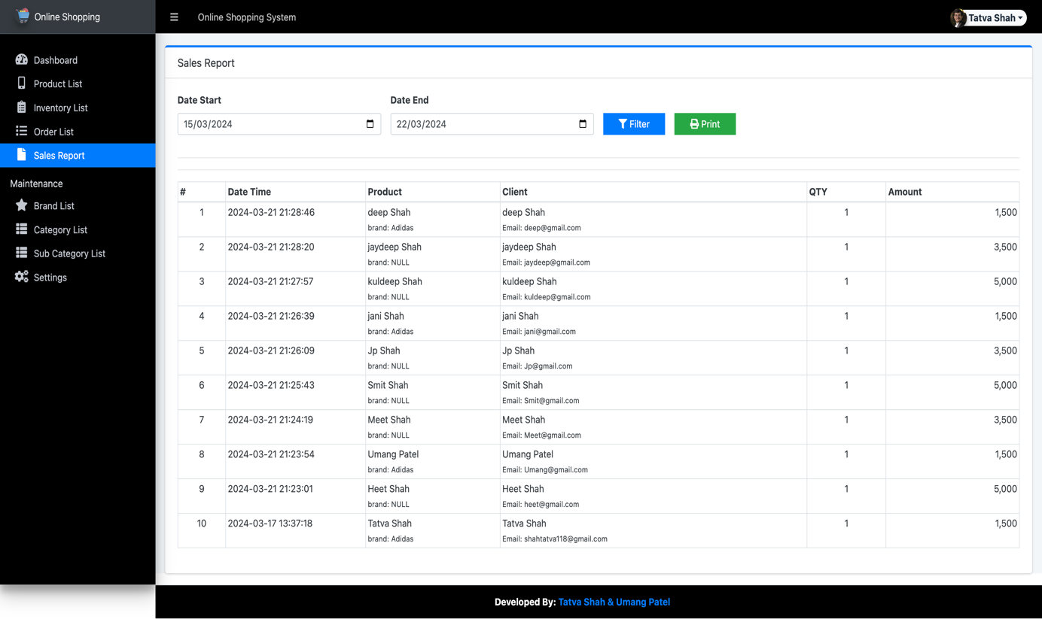

10. Admin Sales Report PDF

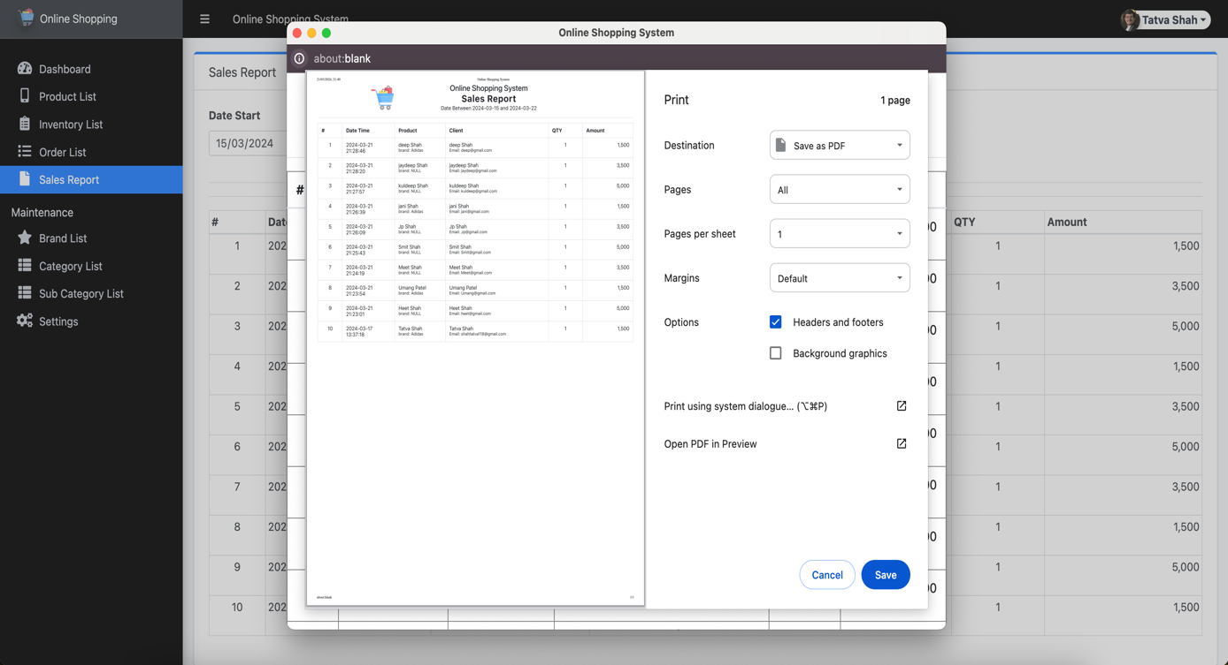

11. Admin Brand list

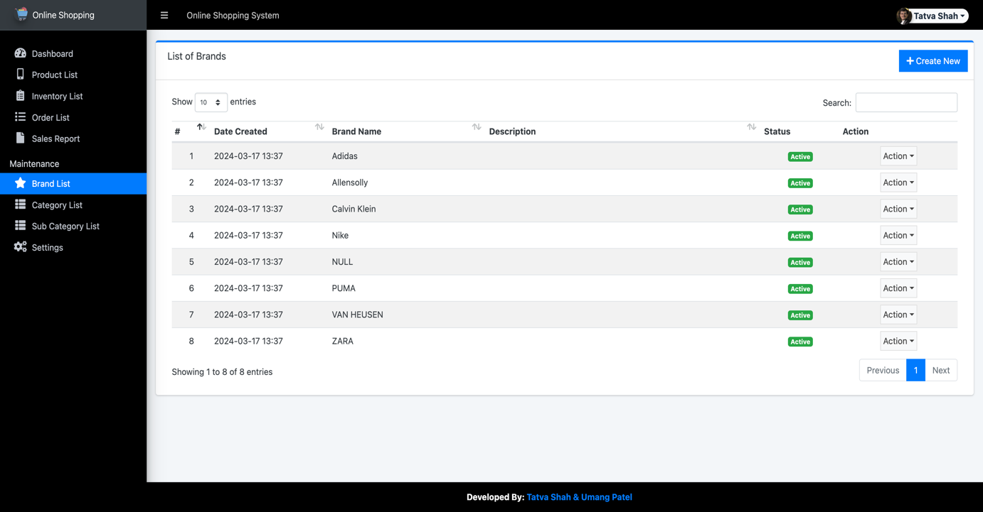

12. Admin Add Brand

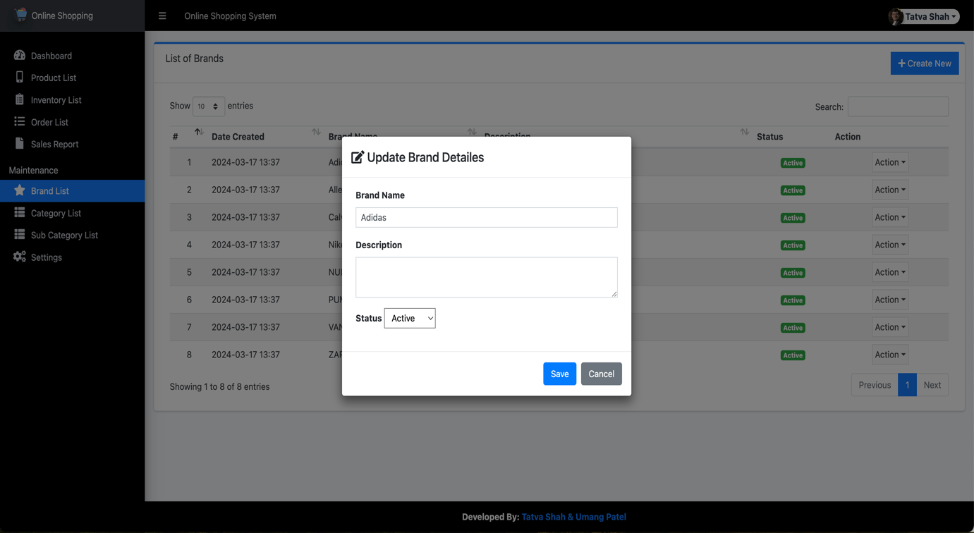

13. Admin Category list

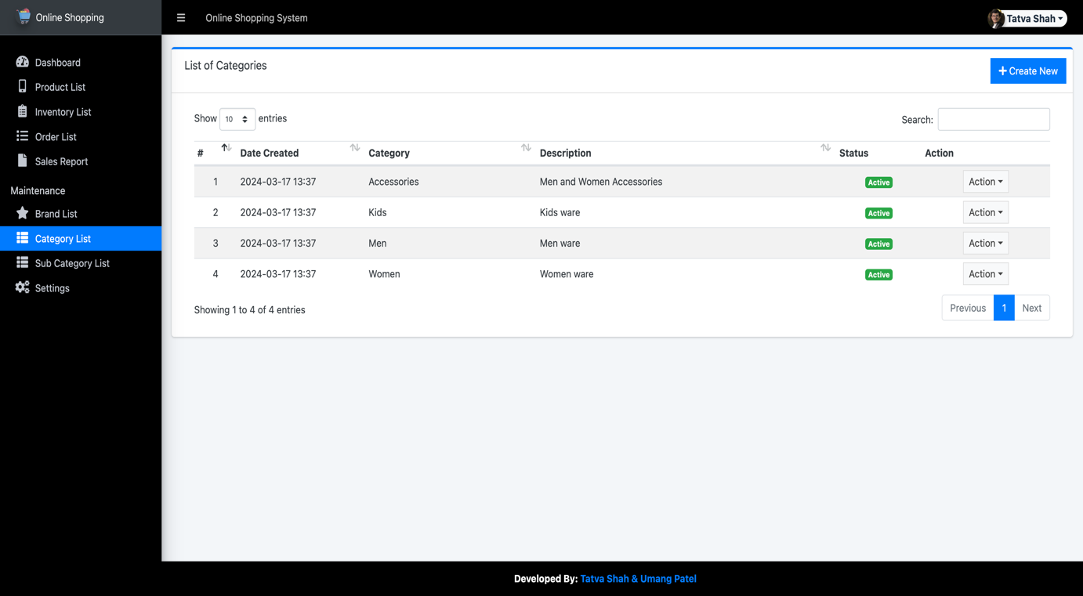

14. Admin Add Category

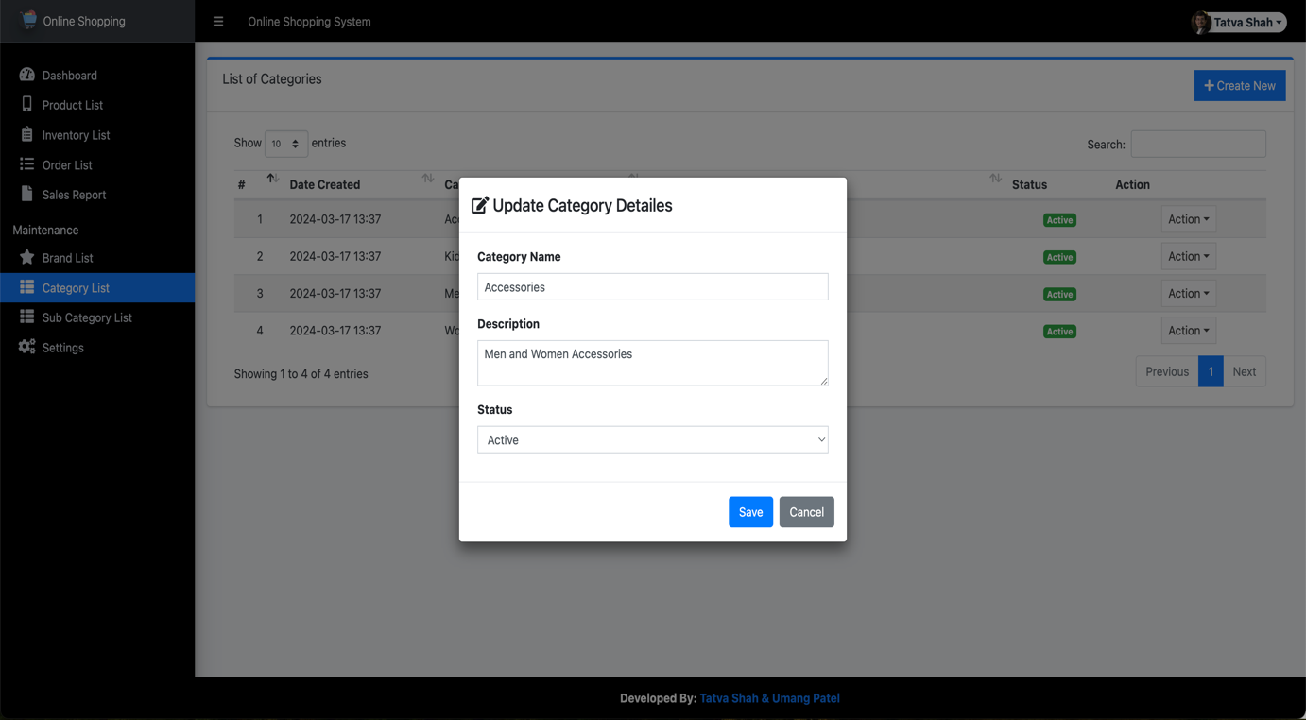

15. Admin Sub-Category list

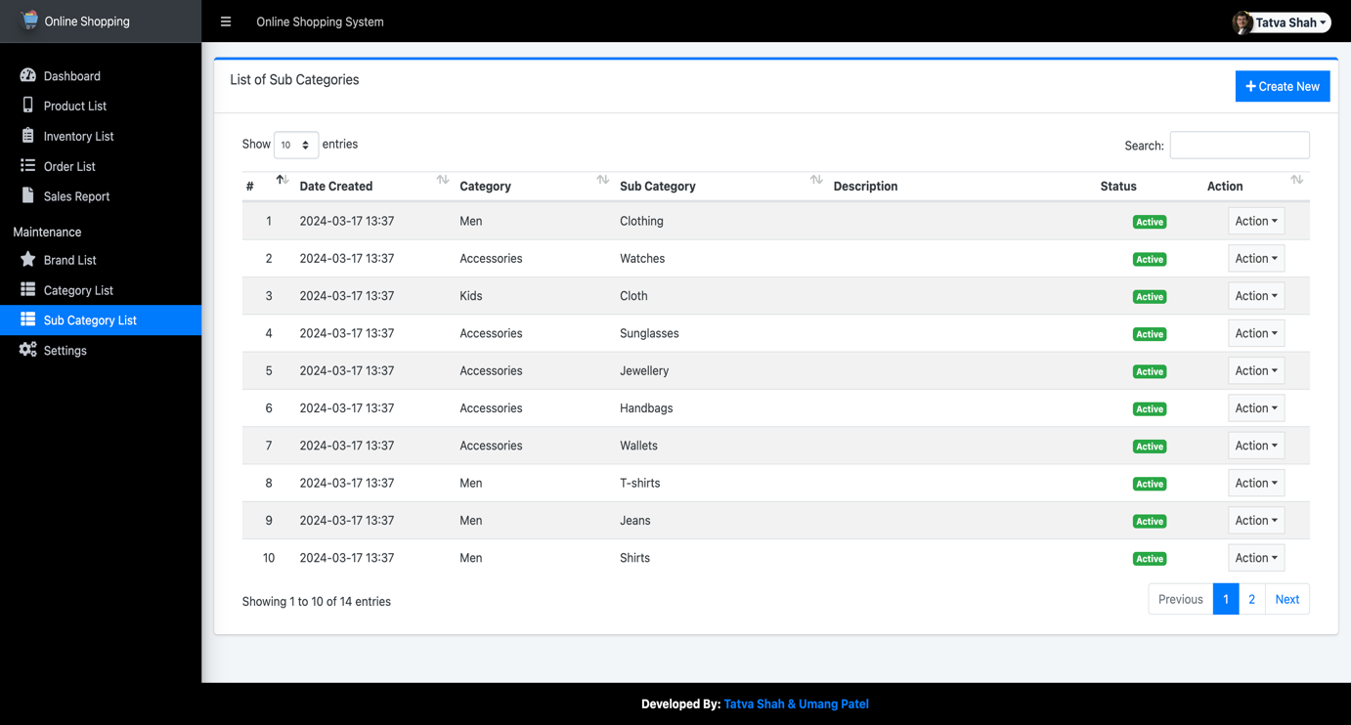

16. Admin Add Sub-Category

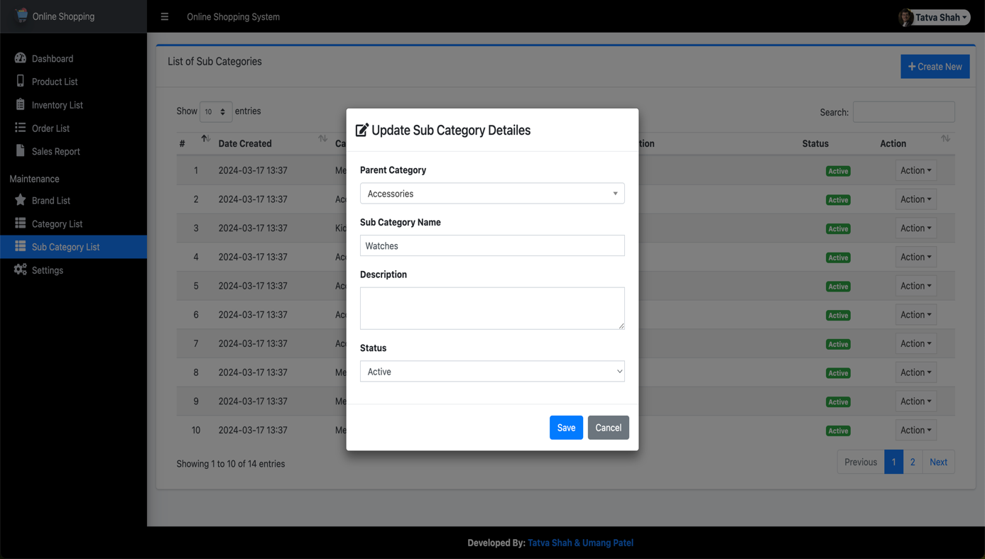

17. Admin Settings

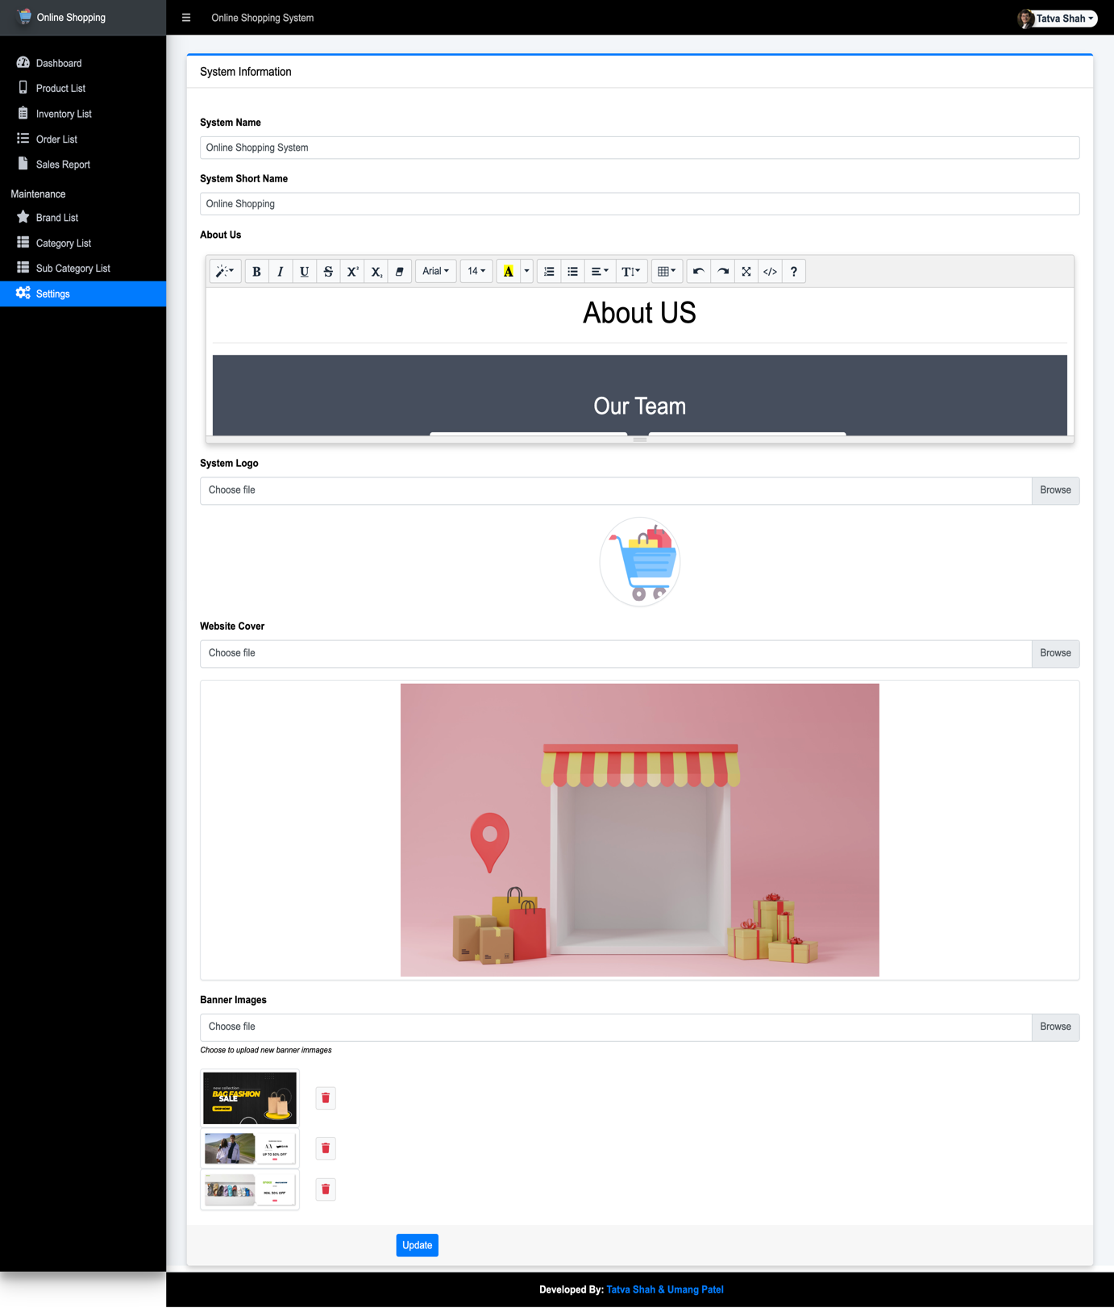

### Customer

18. Customer Registration page

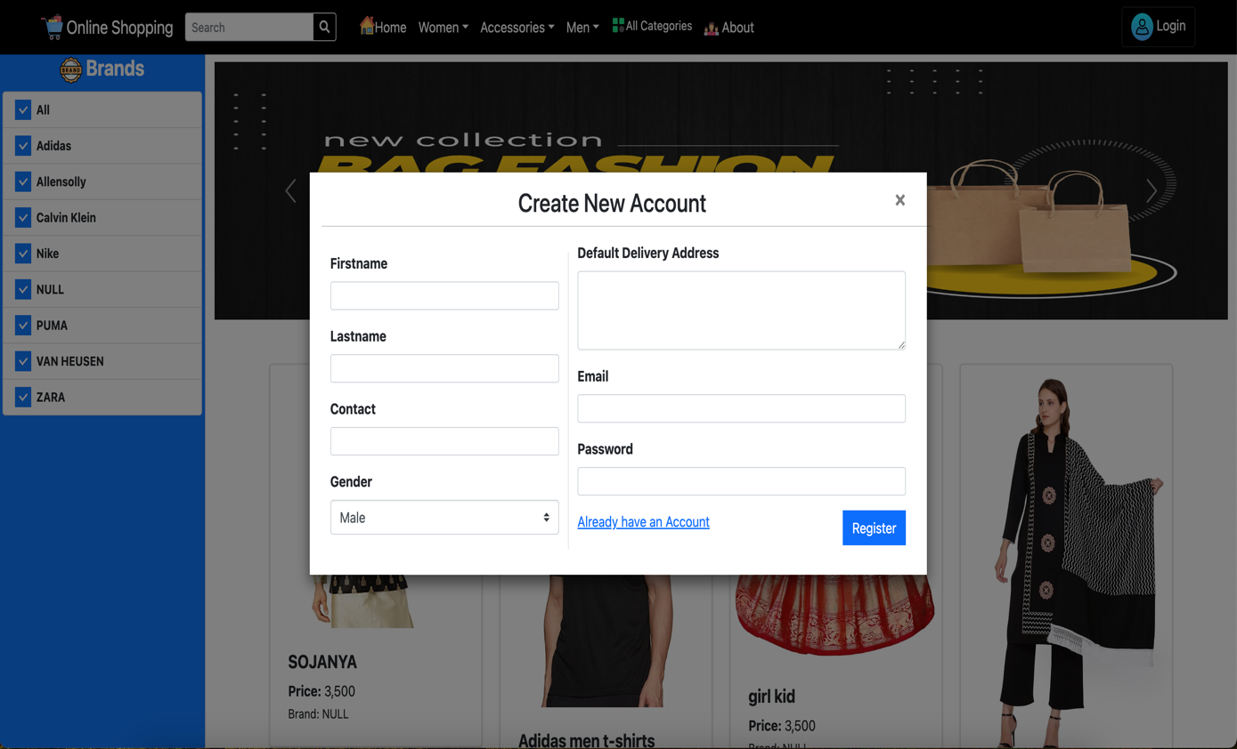

19. Customer Login page

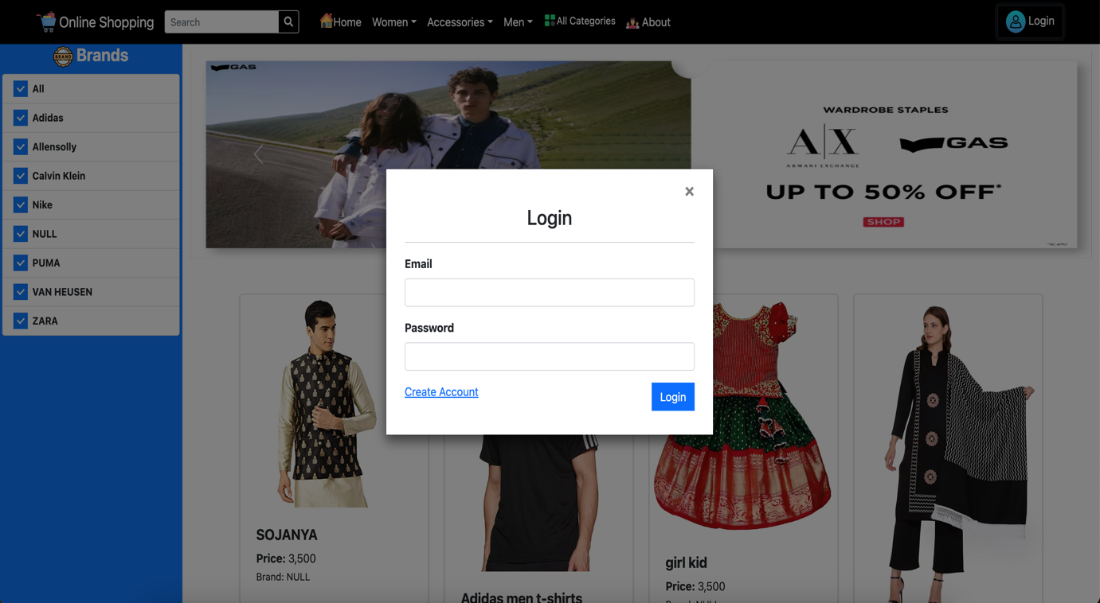

20. Customer Home page

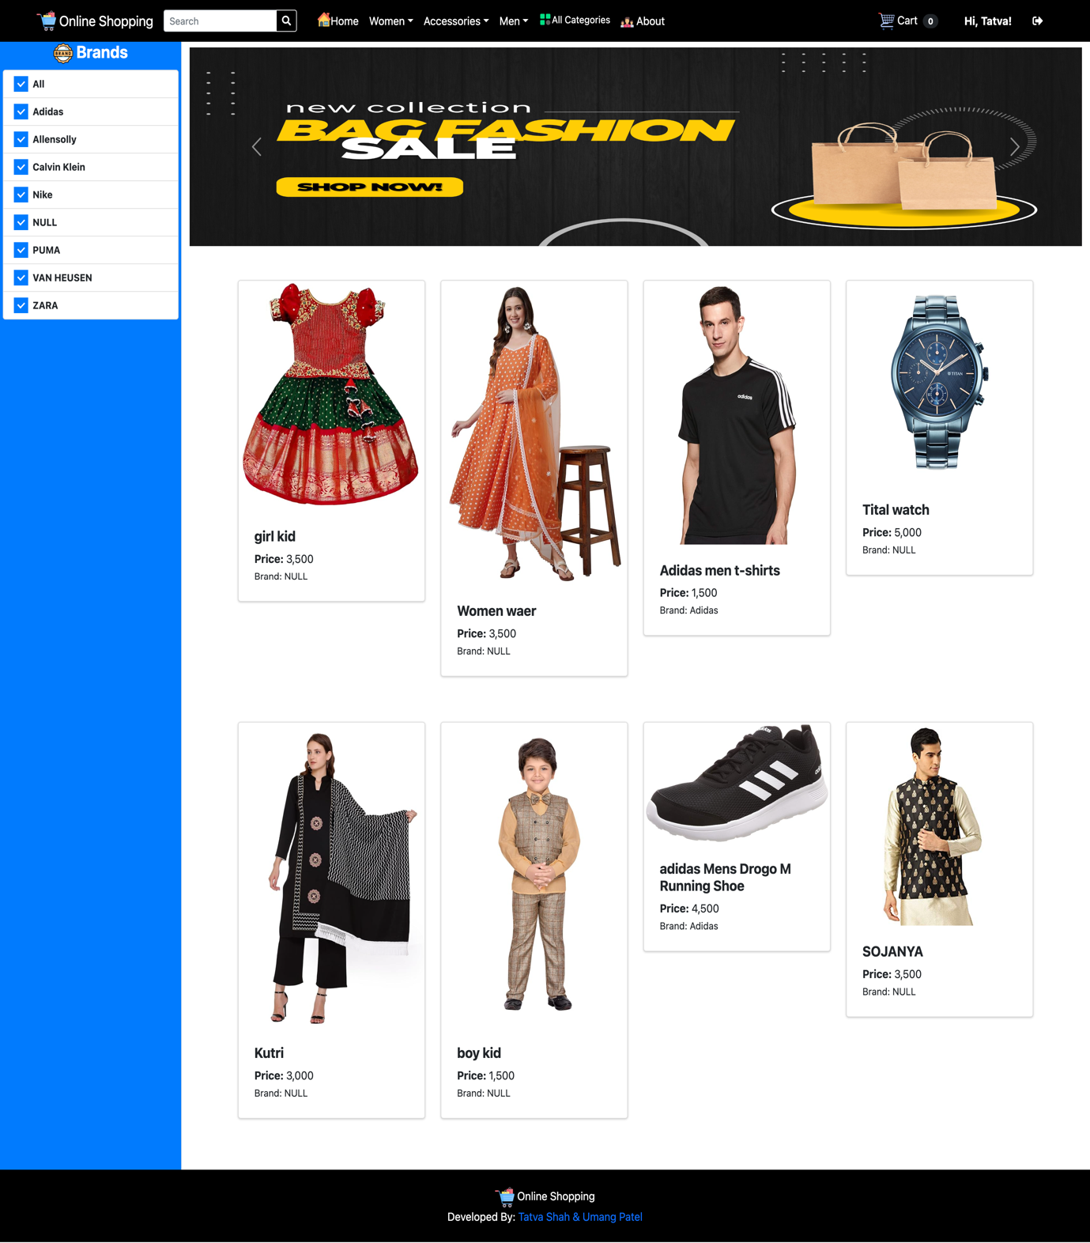

21. Customer View Product

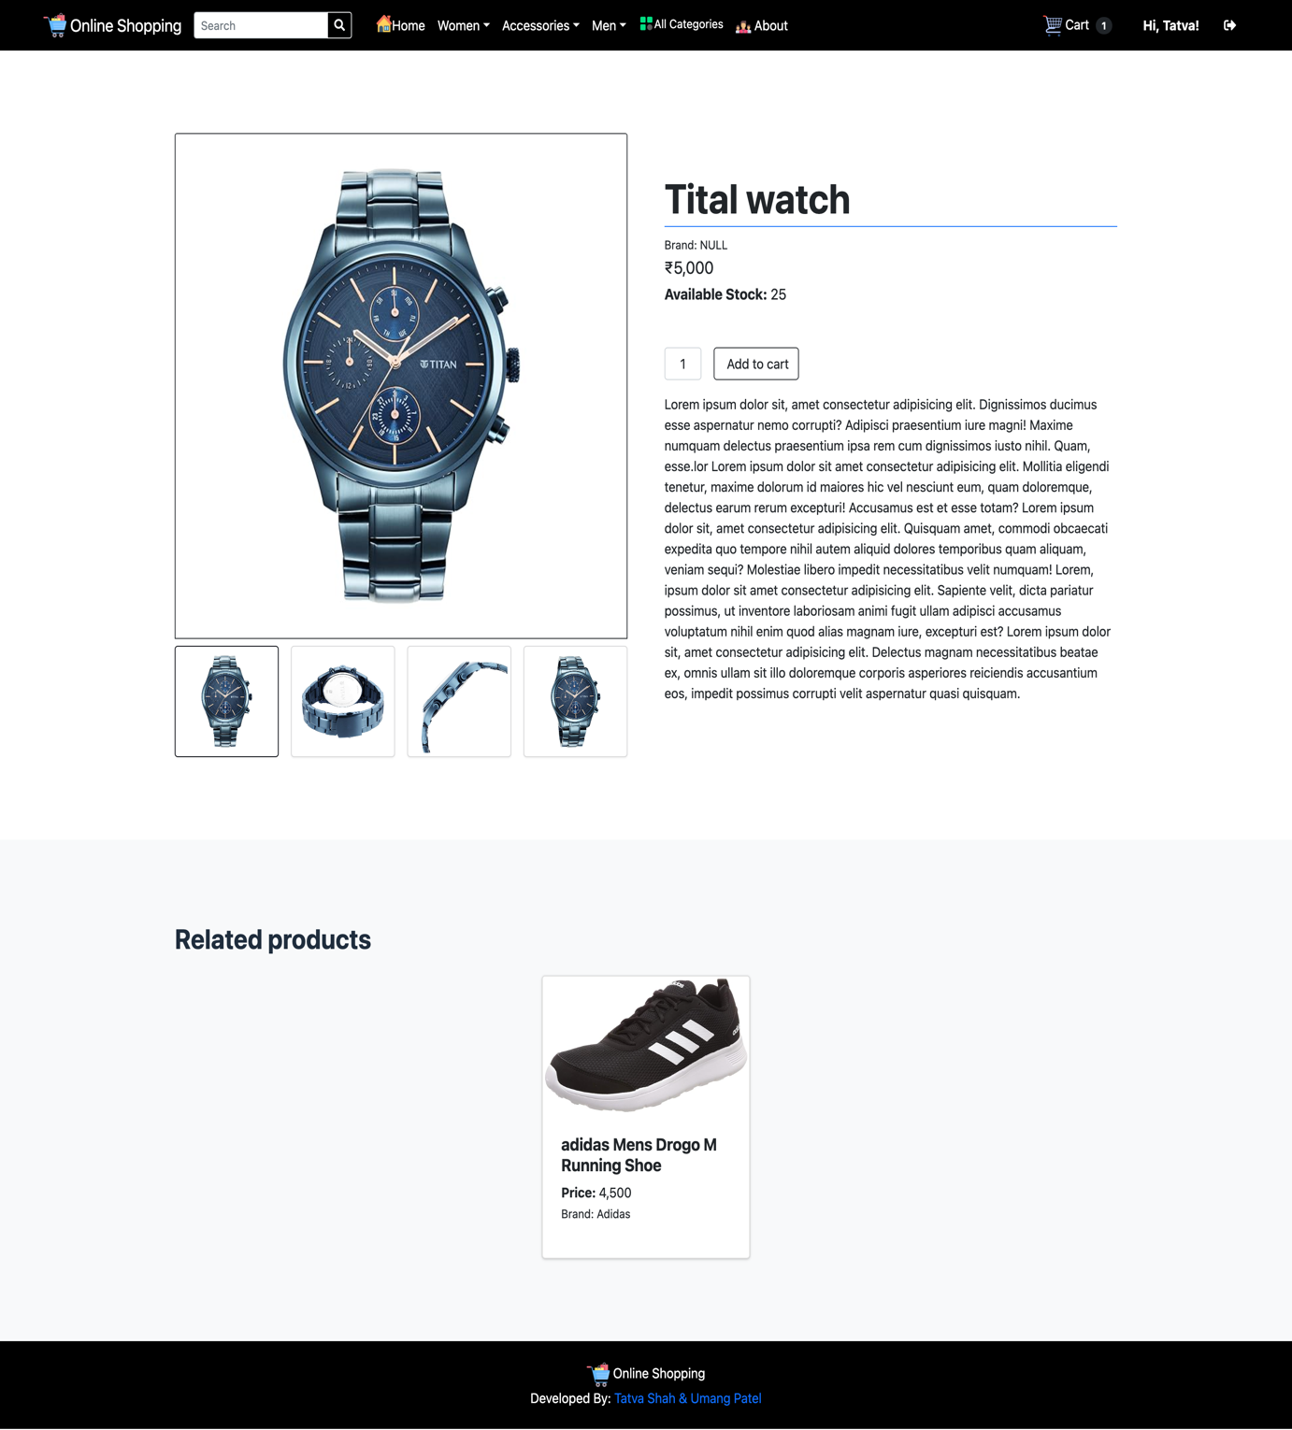

22. Customer All Categories

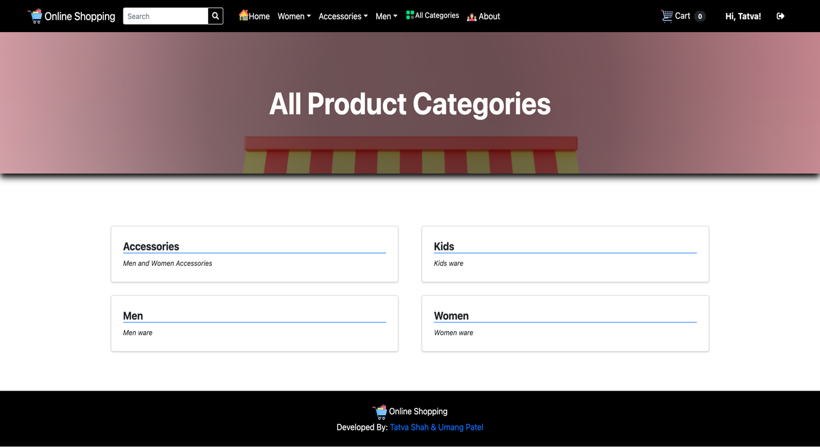

23. Customer Home page

* (Accessories)

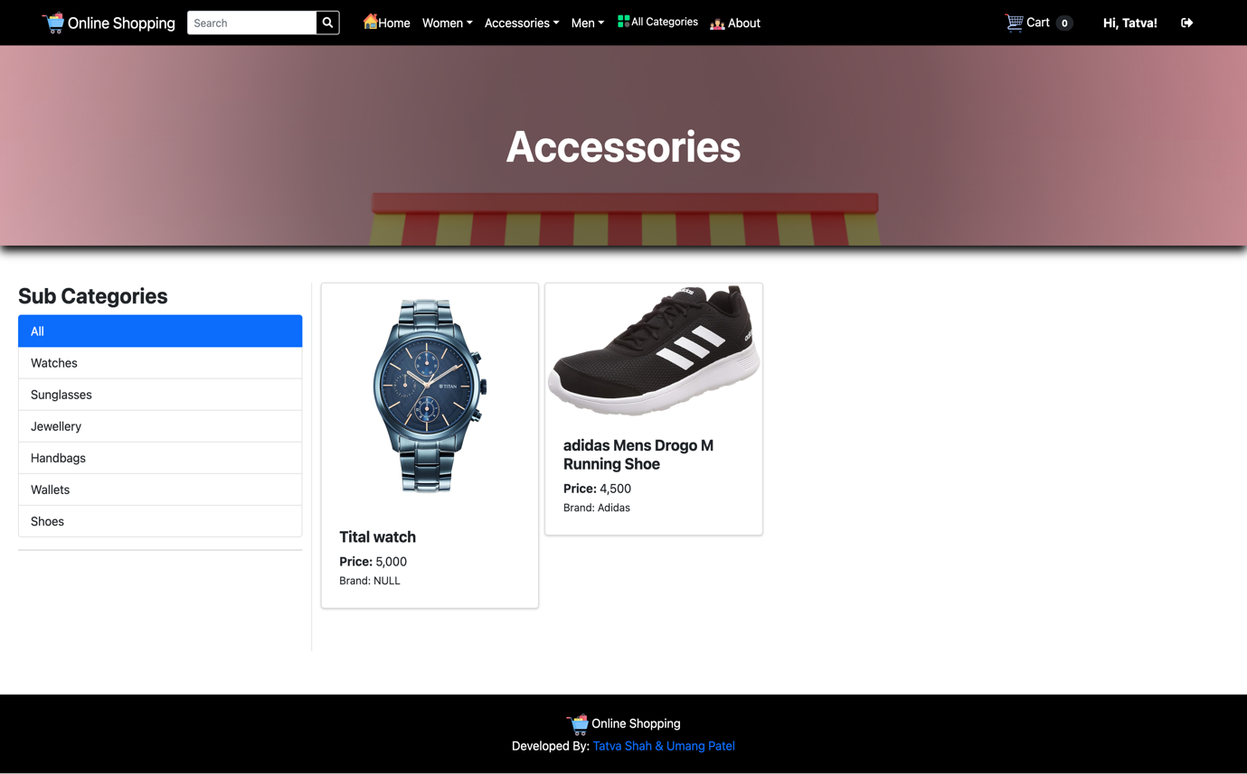

* (Men ware)

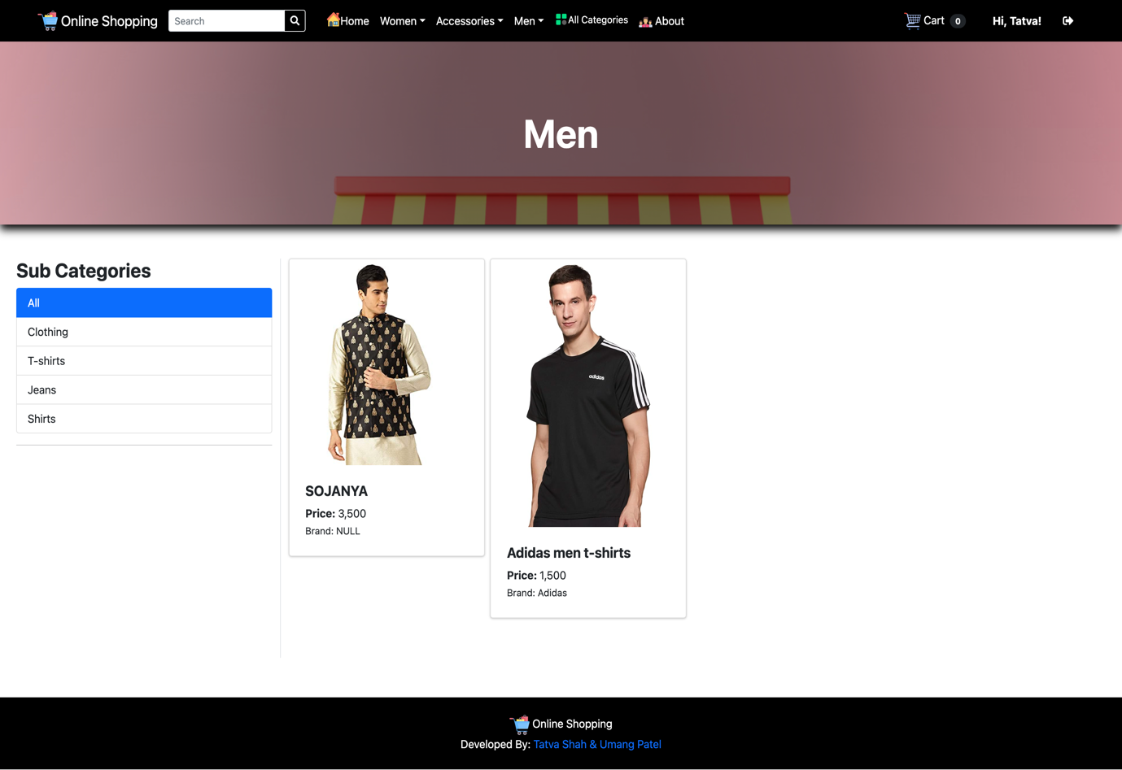

* (Women ware)

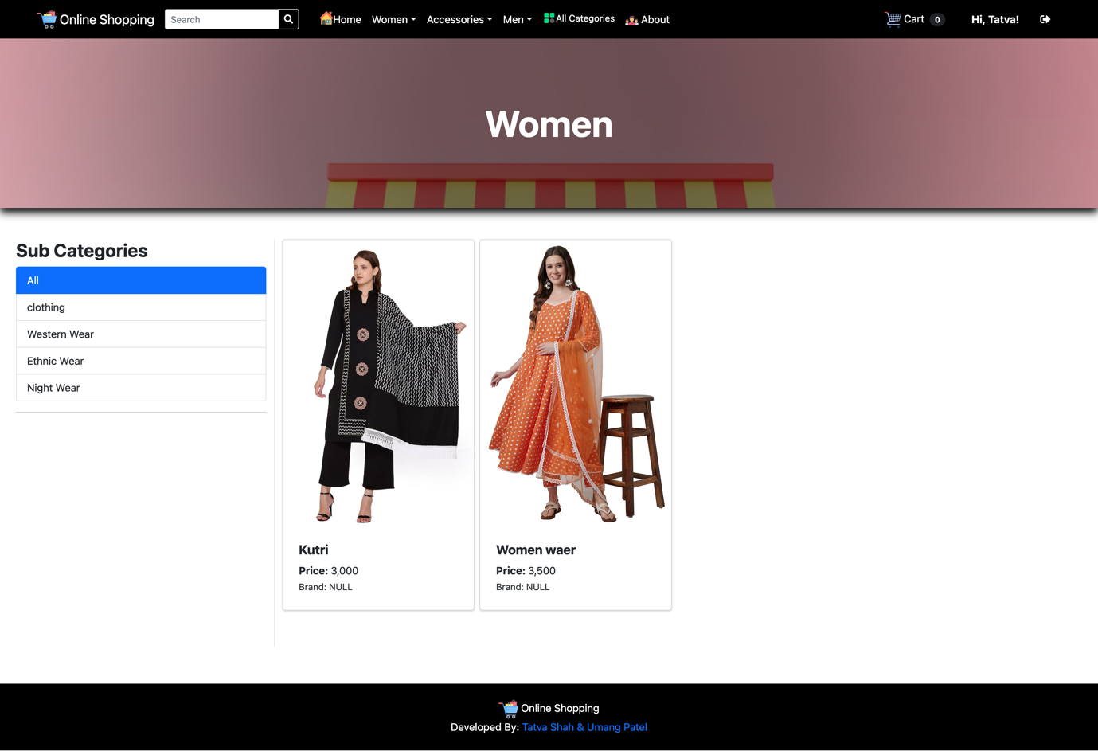

* (Kids ware)

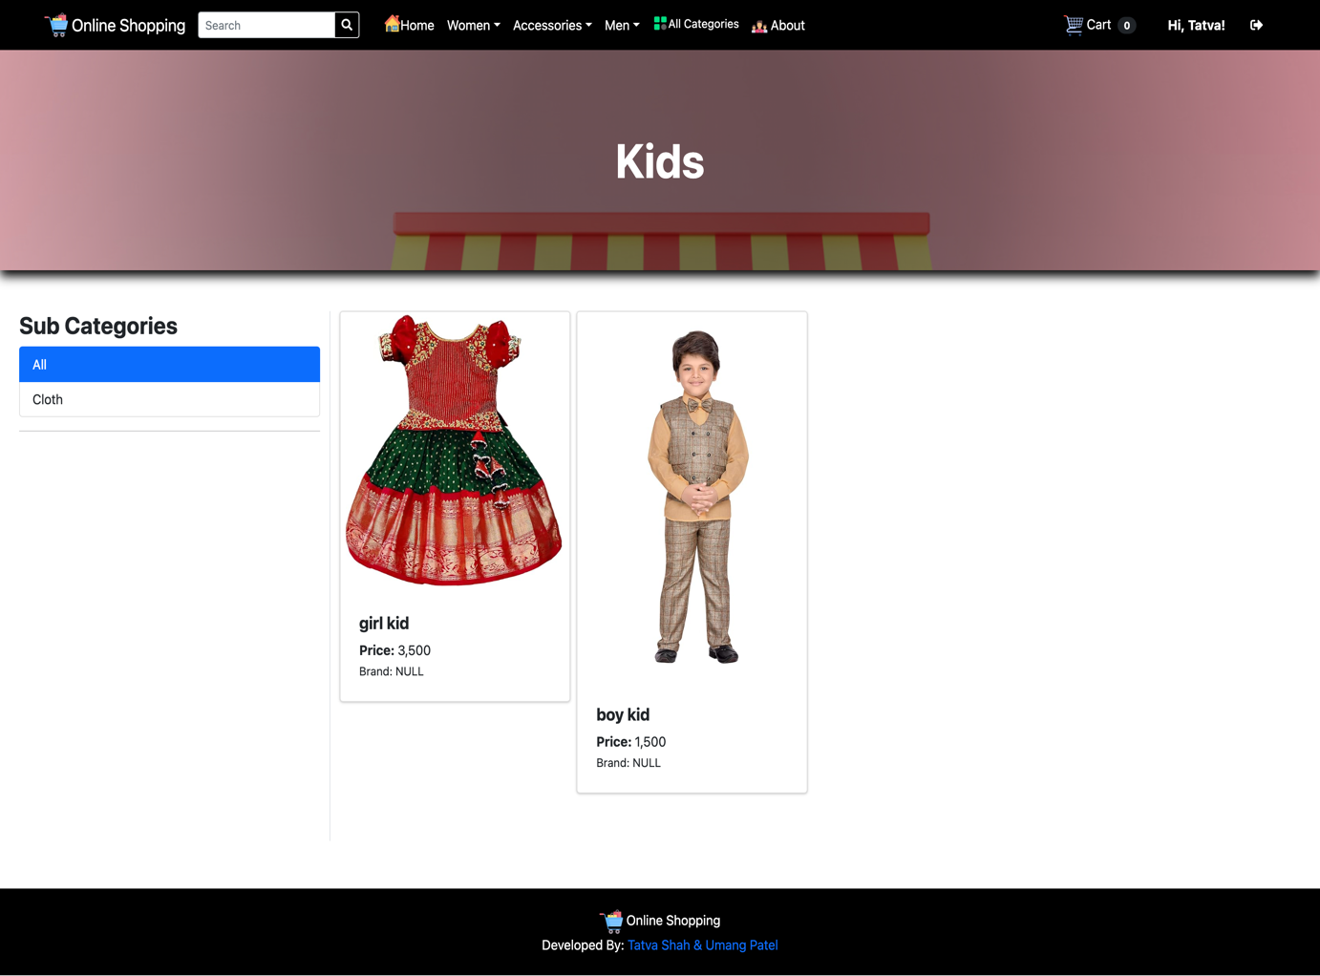

24. Customer Cart List

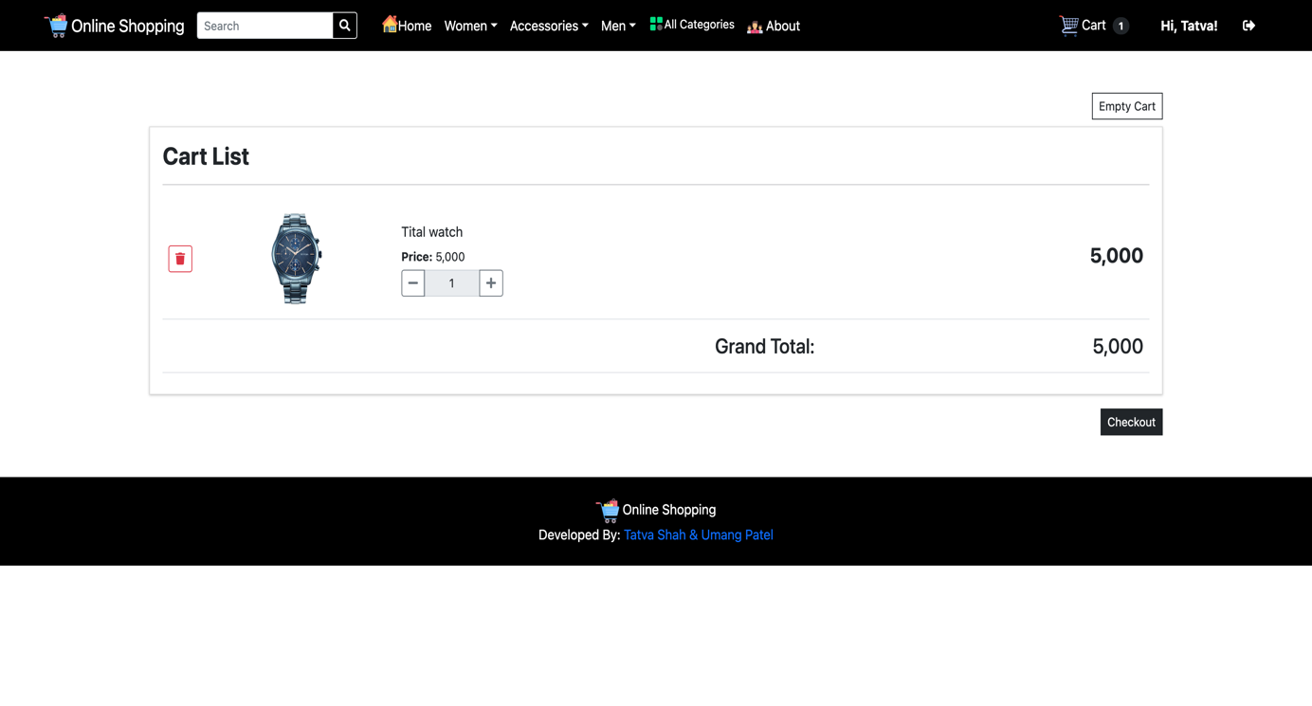

25. Customer Checkout

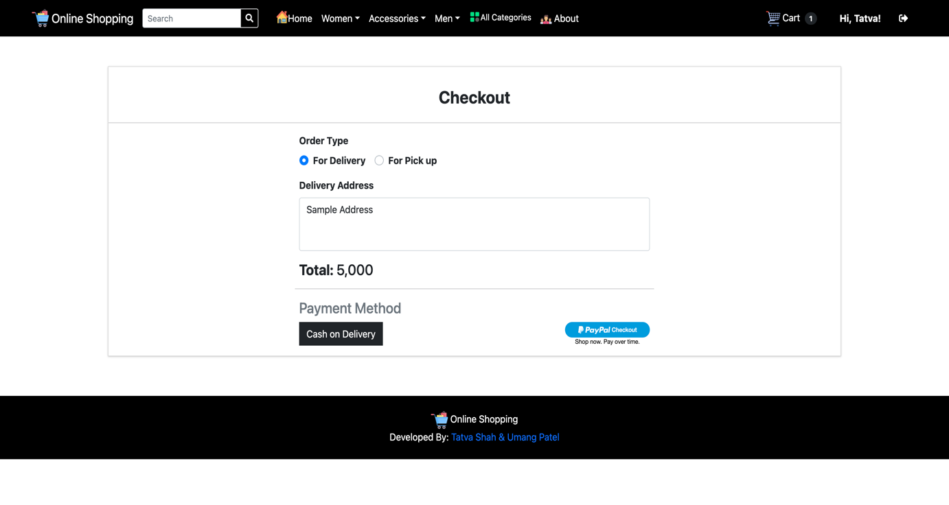

26. Customer Transaction ID

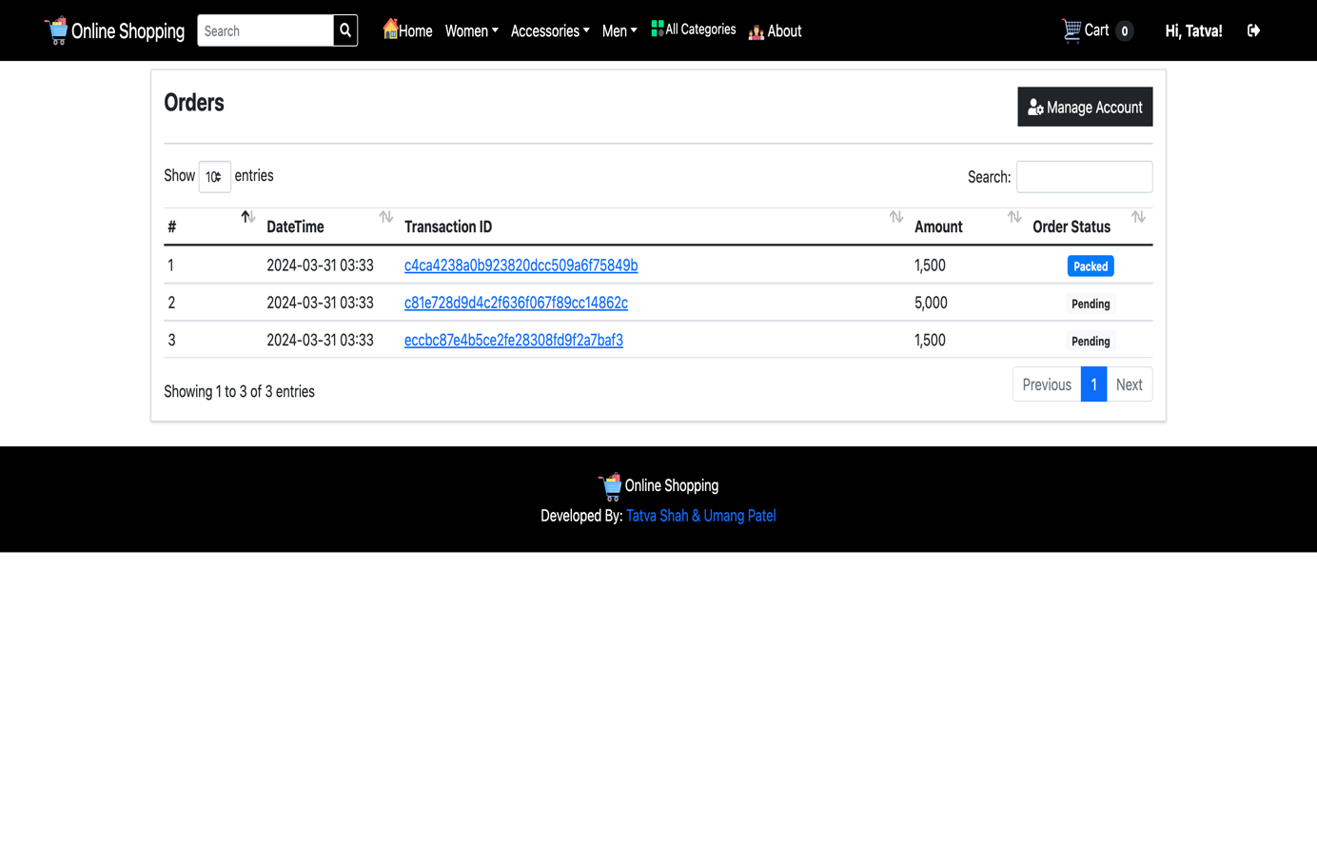

27. Customer Can Edit Profile

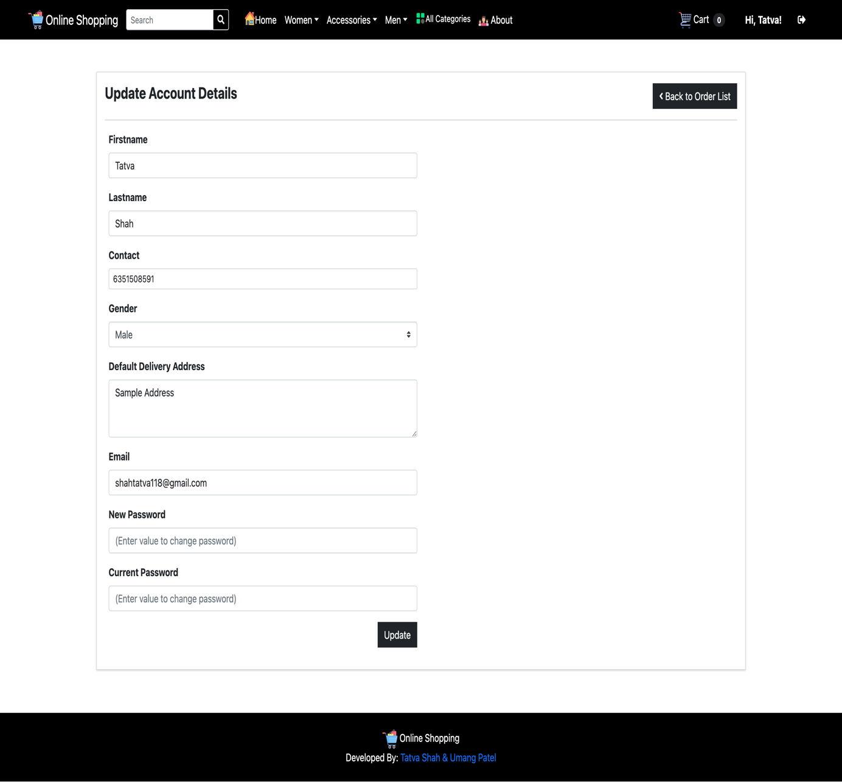

28. About Us

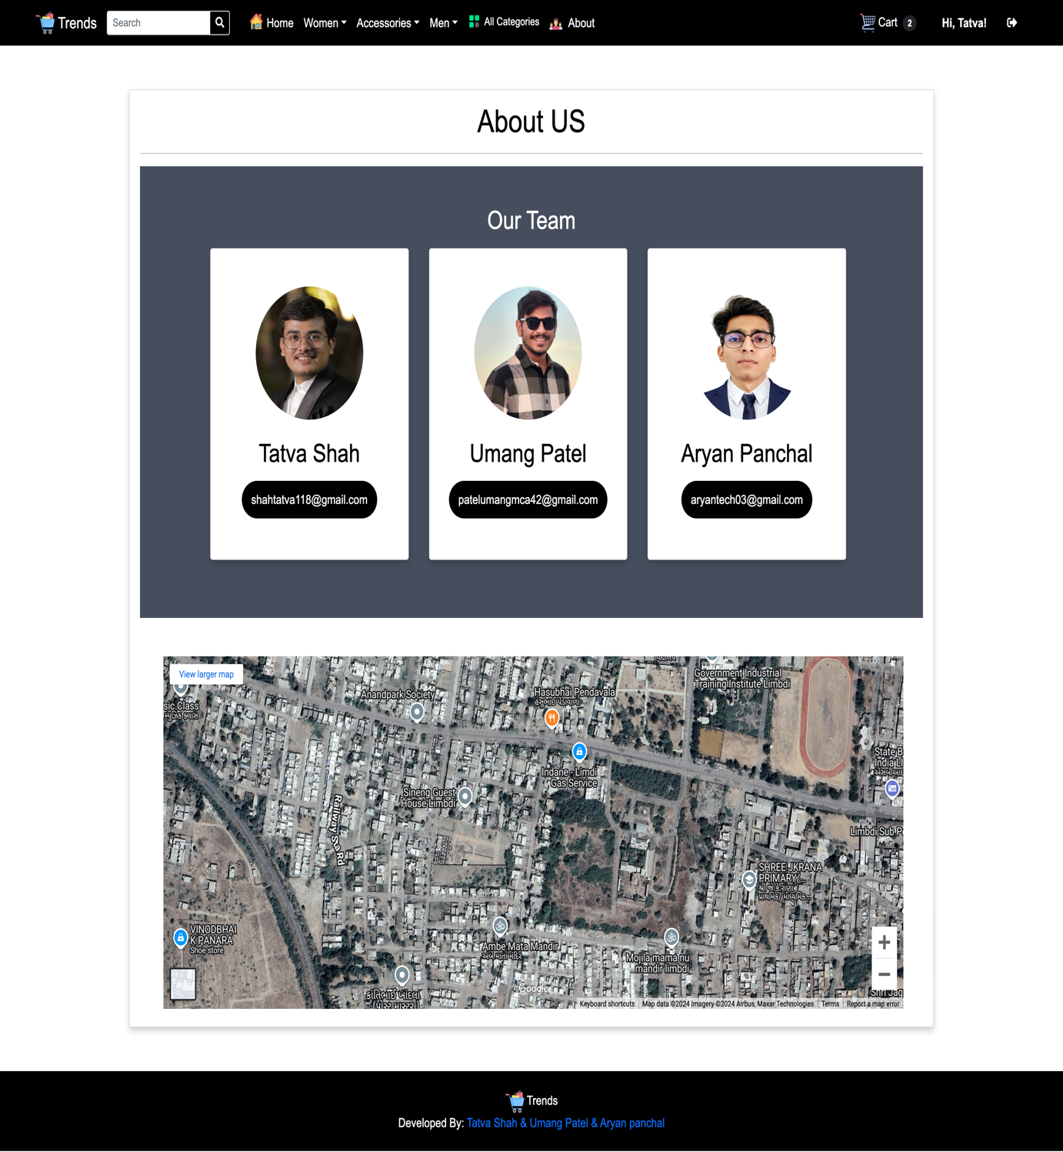

# Agile Documentation

## Agile Project Charter:

|  |  |
| --- | --- |
| General Project Information | |
| Project Name | Online Shopping system |
| Project Champion | Tatva Shah, Umang Patel, Aryan panchal |
| Project Sponsor | LJ Institute of Computer Application |
| Project Manager | Prof. **Pratvi ma’am** |
| Stakeholders | Admin , Customer |
| Expected Start Date | 14/8/2024 |
| Expected Completion Date | 27/9/2024 |

|  |  |
| --- | --- |
| Project Details | |
| Mission | We continuously innovate to be the best Shopping store for our customers. |
| Vision | E-commerce is when we use the internet to conduct business, think of it as an online market which organizes transactions between buyers and store owner. It eases access to many products and encourages international trade by making it more accessible than ever. |
| Scope | Admin can deal in a wide range of products. They can analyse customer buying different products offer, discounts, and services. Business can be easily scaled. By selling via online retail sites like Amazon, Flipkart, etc., |
| Date | 21/08/2024 |

## Agile Roadmap / Schedule

Agile Project Roadmap

|  |  |  |  |  |  |  |
| --- | --- | --- | --- | --- | --- | --- |
| **Sprint** | **Task Name** | **July14** | **July-31** | **Aug-1** | **sept-27** | **oct-14** |
| 1 | Project Structure |  | |  |  |  |
| 2 | Registration |  |  | |  |  |
| 3 | Login and Logout |  |  | |  |  |
| 4 | Forget Password |  |  |  |  |  |
| 5 | Manage Product (Admin) |  |  |  |  |  |
| 6 | Product (User) |  |  |  |  |  |
| 7 | Cart |  |  |  |  |  |
| 8 | Contact Us |  |  |  |  |  |
| 9 | Filters |  |  |  |  |  |
| 10 | Order |  |  |  |  |  |
| 11 | Payment |  |  |  |  |  |

## Agile Project Plan

|  |  |  |  |  |
| --- | --- | --- | --- | --- |
| **Task Name** | **Duration** | **Start** | **Finish** | **Status** |
| **Sprint#1: Project Structure** | 7d | 14/07/2024 | 18/07/2024 | Completed |
| UI Designing | 4d | 14/07/2024 | 14/07/2024 | Completed |
| Database Management | 3d | 18/07/2024 | 18/07/2024 | Completed |
| **Sprint#2: Registration** | 5d | 24/07/2024 | 24/07/2024 | Completed |
| Customer Registration | 5d | 24/07/2024 | 24/07/2024 | Completed |
| **Sprint#3: Login and Logout** | 4d | 28/07/2024 | 30/07/2024 | Completed |
| Customer Login | 2d | 28/07/2024 | 28/07/2024 | Completed |
| Admin Login | 3d | 30/07/2024 | 30/07/2024 | Completed |
| **Sprint#4: Forget Password** | 2d | 02/08/2024 | 02/08/2024 | Completed |
| Customer changes Password | 2d | 02/08/2024 | 02/08/2024 | Completed |
| **Sprint#5: Manage Product (Admin)** | 9d | 03/08/2024 | 03/08/2024 | Completed |
| Add, Update, View, Delete | 9d | 03/08/2024 | 03/08/2024 | Completed |
| **Sprint#6: Product (customer)** | 5d | 12/08/2024 | 17/08/2024 | Completed |
| View Products | 2d | 14/08/2024 | 14/08/2024 | Completed |
| View Product Details | 3d | 17/08/2024 | 17/08/2024 | Completed |
| **Sprint#7: Cart** | 6d | 18/08/2024 | 22/08/2024 | Completed |
| View Cart | 2d | 19/08/2024 | 19/08/2024 | Completed |
| Add and Delete from Cart | 4d | 22/08/2024 | 22/08/2024 | Completed |
| **Sprint#8: Contacts** | 1d | 23/08/2024 | 23/08/2024 | Completed |
| Contact to Admin | 1d | 23/08/2024 | 23/8/2024 | Completed |
| **Sprint#9: Order** | 19d | 1/9/2024 | 19/9/2024 | Completed |
| Customer Place Order | 19d | 19/9/2024 | 19/9/2024 | Completed |
| **Sprint#10: Filters** | 6d | 20/9/2024 | 25/9/2024 | Completed |
| By Product Category | 3d | 22/9/2024 | 22/9/2024 | Completed |
| By Product Size | 2d | 22/9/2024 | 22/9/2024 | Completed |
| By Brand | 3d | 25/9/2024 | 25/9/2024 | Completed |
| **Sprint#11: Payment** | 1d | 27/9/2024 | 27/9/2024 | Completed |
| Cash on Delivery | 1d | 27/9/2024 | 27/9/2024 | Completed |
| Online Payment | 1d | 27/9/2024 | 27/9/2024 | Completed |

## Agile User Story

|  |  |  |  |
| --- | --- | --- | --- |
| **User Story ID** | **As a (type of user)** | **I want to (perform some task)** | **So that I can (achieve some goal)** |
| **1** | Admin | Manage Login Module | Ensure that validate user can join |
| **2** | Admin | Manage Product | Insert, Update Delete and View the product |
| **3** | Admin | Manage order | Ensures the order information is valid |
| **4** | Visitor | View Product | View products  according to categories |
| **5** | Customer | View Product | View products according to  categories |
| **6** | Customer | Add to Cart | Products are added to cart to buy bunch of products in single order |
| **7** | Customer | Order product | To see what they had purchase in the past |
| **8** | Customer | Make Payment | Payment for the order |
| **9** | Customer | Search Product | Search products according to their requirement |
| **10** | Customer | Order | Order products |